

**Banner Document Management**

**Training Guide**

**East Tennessee State University**

# Revisions

|  |  |  |  |
| --- | --- | --- | --- |
| Revision # | Date | Author | Reason |
| 1 | 2/25/2015 | Tom Donohoe | Initial Draft |
| 2 | 3/24/2015 | Josh Whitlock | Consolidation |

Table of Contents

Revisions 2

Table of Contents 3

I. Purpose 5

II. Getting Started: Adding Documents 5

A. Using the Interactive Client 5

Add a Document with the “New Page” Options 6

Add a Document with the Scan Icons 8

B. Navigating Displayed Document Pages in the Interactive Client 9

C. Icons for Document Display 9

D. Icons for New Document 10

E. Icons for New Document Viewer 10

F. Icons for New Document Scan 10

G. Icons for Document Viewer (Row 1) 11

H. Icons for Document Viewer (Row 2) 12

III. Indexing Documents 13

A. Starting the Indexing Process: 13

B. Finishing the Indexing Process 14

C. Open Batches for Indexing 14

D. Delete or Skip a Scanned Page from a Batch 16

E. Move a Page to another Batch 16

F. Add Pages to a Batch 18

G. Rotate Indexed Pages 19

H. Re-order Indexed Pages 20

Page Menu Option 20

Thumbnail View Option 21

I. Icons for Indexing Documents 21

IV. Document Query and Retrieval 22

A. Begin a Query 22

B. Enter Query 23

C. New Query Toolbar Icons 23

D. View Results 24

E. Advanced Queries 24

Wildcard searches: 25

List of Values Search 25

F. Icons for Query Results 26

V. System Setup 27

A. AppXtender User Settings 28

Manage Interactive Viewer 28

Mange Document View Settings 30

Manage Search / Result Settings 32

B. Internet Explorer Setup 33

C. Scanning Components 37

# Purpose

This document is meant to provide step-by-step training for BDM at ETSU. The document is divided into multiple sections according to how you use BDM. Depending on your access, you may not be able to access all features shown below.

# Getting Started: Adding Documents

Documents can be added to BDMS by scanning in paper, importing electronic documents, or cutting and pasting text from emails or other documents.

**NOTE:** Every image imported, scanned or copied into BDMS is automatically assigned to a batch whose name is a combination the ID of the BDMS user and the date/time stamp. Once added, the images can be processed immediately or can be processed later by accessing the batch from the batch list.

To begin, select the application (file cabinet) to which the documents should be added and right click your mouse. Select **New Document** from the context menu.

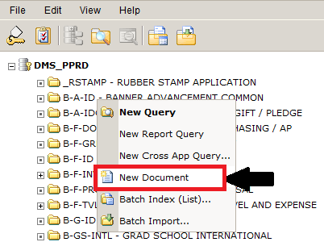

## Using the Interactive Client

In the Interactive Client, the document viewer appears as seen in the figure below. Several options are available for adding documents:

1. Using the “New Page” option on the top right toolbar to:

* scan paper
* copy and paste text
* import electronic documents

1. Scanning paper using the Scan icons on the third row of the toolbar.

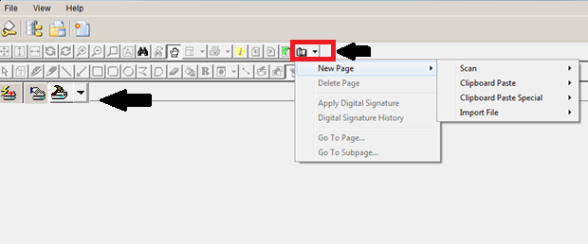

### Add a Document with the “New Page” Options

To scan in a paper document, select “Scan”. See **“Add a Document by Scanning”**

**Clipboard Paste**

The “Clipboard Paste” option allows users to paste a document from the Windows clipboard or Microsoft Outlook; these documents are considered ‘COLD’ files.

**Clipboard Paste Special**

The “Clipboard Paste Special” option allows users more options for pasting a document from the Windows clipboard or Microsoft Outlook.

**Import File**

The “Import File” option will bring up an Import File dialog from which to browse for the correct file as seen below. Follow these steps:

1. Navigate to the file.
2. Select the File.
3. Click Open.
4. The first page of imported document will appear in Document Viewer. Options to edit the document will appear in the toolbar.
5. Continue importing files as needed.

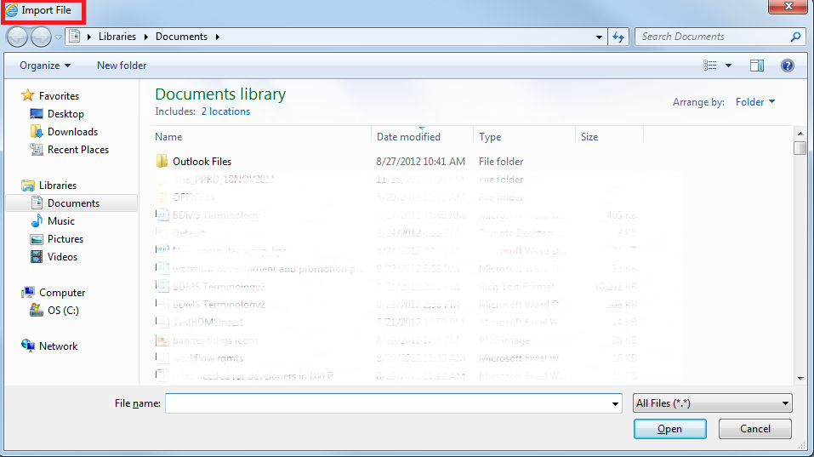

1. The documents are ready to be added to BDM with an index. See the following sections for instructions on working with Indexes:
   * Indexing Documents
   * Icons for Indexing Documents
2. You may choose to index the documents later; if so, the file will appear in the batch list; the batch will be named with a combination the ID of the BDMS user and the date/time stamp.

### Add a Document with the Scan Icons

**Caution!**

Please note the following before scanning paper documents:

* + ApplicationXtender Web Access must be configured to use the IRC viewer in order to access AppXtender Scanning Component scanning functionality.
  + Remove sticky notes and paperclips
  + Orient all papers the same way
  + If needed, select the scanner and options for the documents you need to scan from the Scanner options shown below:

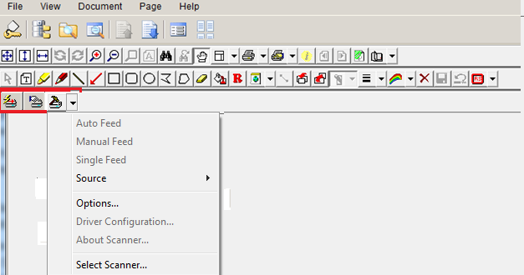

To scan paper document follow these steps:

1. Load the documents into the scanner
2. Use one of the following options:
   1. Use the option available from the “New Page” icon in the top right toolbar
   2. Click the appropriate scan feed button to start scanning
      1. Auto Feed: 
      2. Manual Feed: 
3. The documents are ready to be added to BDM with an index. See the following sections for instructions on working with Indexes:
   1. Indexing Documents
   2. Icons for Indexing Documents
4. You may choose to index the documents later; if so, the file will appear in the batch list; the batch will be named with a combination the ID of the BDMS user and the date/time stamp.

## Navigating Displayed Document Pages in the Interactive Client

Use the “Previous Page” and “Next Page” buttons in the first row of the Document View frame toolbar to navigate multi-page documents.

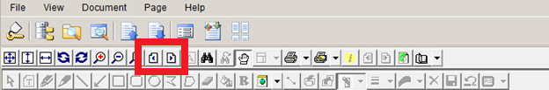

You can also click the Thumbnail icon to view all of the pages in the document.

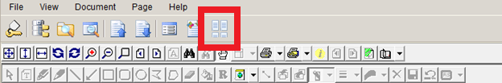

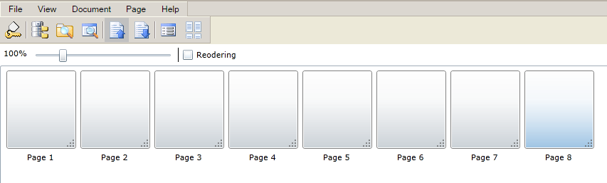

## Icons for Document Display



|  |  |
| --- | --- |
| **Button** | **Description** |
|  | Logout (Always logoff before closing your window) |
|  | Display Applications List view |
|  | New Query |
|  | Display Application Query Results for the most recently run query |
|  | Goto Previous Document |
|  | Goto Next Document |
|  | Display Index view for the current open document |
|  | Toggle between Thumbnails view and the thumbnails contact sheet |

## Icons for New Document



|  |  |
| --- | --- |
| **Button** | **Description** |
|  | Logoff (Always logoff before closing your window) |
|  | Application List |
|  | Batch List |
|  | New Document |

## Icons for New Document Viewer

When starting a new document, the toolbar functions are limited until pages are added or scanned into the batch.

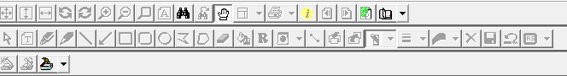

|  |  |
| --- | --- |
| **Button** | **Description** |
|  | Refresh the viewing area (Row 1) |
|  | Menu of NewPage options (Row 1) |
|  | Display information about the page (Row 1) |
|  | Search for text in the displayed page (Row 1) |
|  | Scan (Row 3) |

## Icons for New Document Scan



|  |  |
| --- | --- |
| **Button** | **Description** |
|  | AutoFeed |
|  | Manual Feed |
|  | Scan |

## Icons for Document Viewer (Row 1)



|  |  |
| --- | --- |
| **Button** | **Description** |
|  | Fit displayed page in the Document View area |
|  | Fit displayed page in the viewing area from top to bottom |
|  | Fit displayed page in the viewing area from left to right. |
|  | Rotate displayed page 90 degrees left |
|  | Rotate displayed page 90 degrees right |
|  | Zoom in on displayed page |
|  | Zoom out on displayed page |
|  | Magnify a specific area of the displayed page. When you select the button, the mouse pointer becomes a magnifier. When you position the magnifier and click the mouse, the selected region of the document appears in the Magnifier dialog box. |
|  | Display the text or image for the displayed page |
|  | Display previous page of multi-page document. This button appears only  when you view a multi-page document or batch document |
|  | Display next page of multi-page document. This button appears only  when you view a multi-page document or batch document |
|  | Display previous version of document - appears only when more than one version |
|  | Display next version of document- appears only when more than one version |
|  | Search for text in the displayed page |
|  | Continue searching for the text entered in the text Search dialog box |
|  | Switch between pan mode and selection mode. |
|  | Displays or hides form overlays on COLD/ERM documents |
|  | Print current page and all or a range of subpages. |
|  | Print the document or PDF file and all or a range of pages |
|  | Display information about the page |
|  | Display next subpage |
|  | Display previous subpage |
|  | Refresh the viewing area |
|  | Opens the Select Files for Batch Import window |
|  | Menu of NewPage options |

## Icons for Document Viewer (Row 2)



|  |  |
| --- | --- |
| **Button** | **Descriptions** |
|  | Select Annotation Item |
|  | Text |
|  | Highlight |
|  | FreeHand |
|  | Line |
|  | Arrow |
|  | Rectangle |
|  | Rounded Rectangle |
|  | Oval |
|  | Polyline |
|  | Polygon |
|  | Use Eraser |
|  | Fill |
|  | Create redaction |
|  | Set default group |
|  | Select All |
|  | Move selected item to front |
|  | Move selected item to back |
|  | Show/Hide |
|  | Select line Width |
|  | Select Color |
|  | Delete Item |
|  | Save changes to document |
|  | Cancel changes to document |
|  | Rubber Stamp |

# Indexing Documents

After documents are in BDM, they must be indexed for storage and retrieval. The index is one or more descriptive fields identifying a specific document in an application (for example, last name, ID, document id, purchase order, etc.). The information in these fields is used to both store and retrieve specific documents from AppXtender. This information must be entered when the document is indexed.

## Starting the Indexing Process:

1. Click “New Document” 
2. Enter appropriate information from the document into each required index field. Index fields in **“Bold”** must be entered. If the first Index field is “ID”, enter the ID, and hit tab; fields such as “Name” and “PIDM” will be populated. The Index document view is shown below.

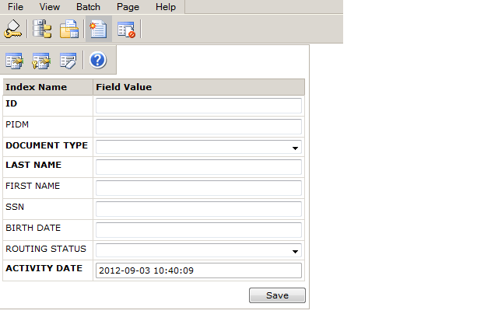

1. Click “Save” when all fields have been entered for the first page

**NOTE:** Once the document is saved, the “Save” becomes a “Modify”, and you may change the KEY values only.

## Finishing the Indexing Process

Batches can contain single page documents, multi-page documents, or multiple documents or all of the above. For single page documents, you enter the required index information and select Save to create the new AppXtender document.

1. If the batch is a single-page document, the process is complete.
2. If pages remain in the batch you may attach pages to the current document without re-indexing the index information.
   1. To attach all batch pages to the current document:
      1. From the Index view toolbar, select the “Attach All Pages” button. 
   2. To attach some but not all batch pages to the current document:
      1. Select a page in the batch viewer
      2. From the Index view toolbar, select the “Attach Current Page” button. 
      3. The selected page is removed from the batch and appended to the current document, and the AppXtender document is saved. The next page in the batch appears in the viewer.
      4. Repeat steps for each batch page to be attached to the current document.
3. If pages are still in the current batch, repeat the process beginning with Step 1 above, clicking “New Document” 

## Open Batches for Indexing

You do not have to index documents immediately after scanning them. If you need to logout of BDM, the documents will be kept in a batch until you either index them, delete them from the batch, or delete the batch. Follow thsese steps to reopen an existing batch and begin the indexing process:

1. From any point in WebXtender, click the “Batch List” icon:



1. From the Applications list, right click the Application name and choose “Batch Index (List)”

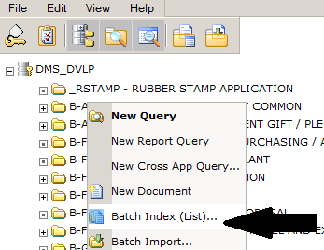

1. Make certain the Current Application is correct. If you index a batch of documents incorrectly, you risk “losing” all of those documents in the system.

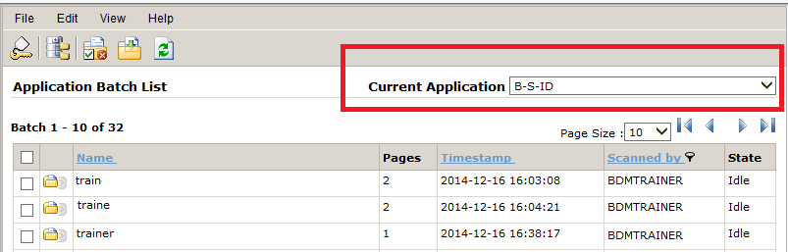

1. Select the Batch from the list by double clicking on the folder icon to the right of the batch you need:

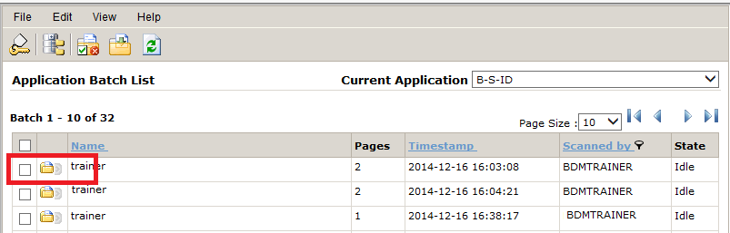

## Delete or Skip a Scanned Page from a Batch

To **skip** a page while processing a batch, use the page navigation buttons while indexing:

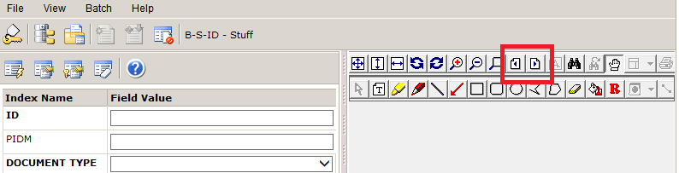

To **delete** a page in a batch while processing, do the following:

1. Select the page from the page index in the left of the screen.
2. Click the "Page menu" icon.
3. Choose "Delete Page"

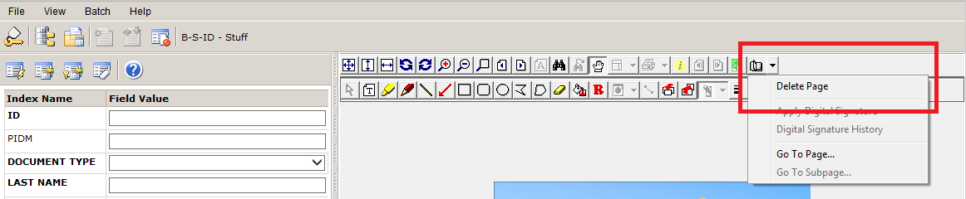

## Move a Page to another Batch

To move a page, click the **Return to Batch Scanning** icon.

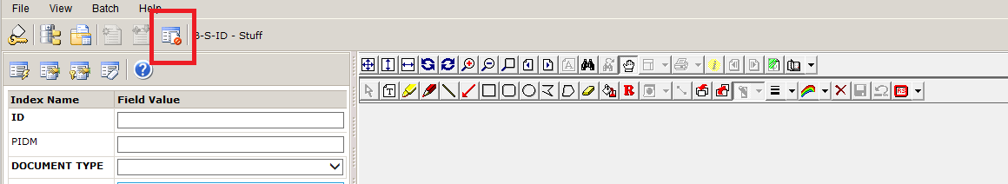

Use the “Next Page” or “Previous Page” buttons to navigate to the page that you want to move to another batch. From the Menu, click **Batch** and select **Copy or Move Pages**.

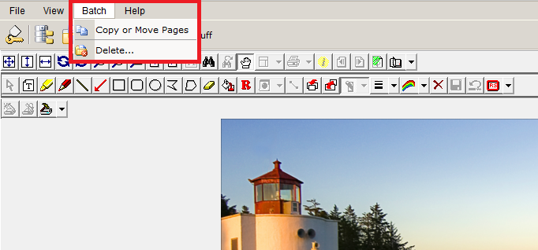

The following options will appear to the left of the document viewer window.

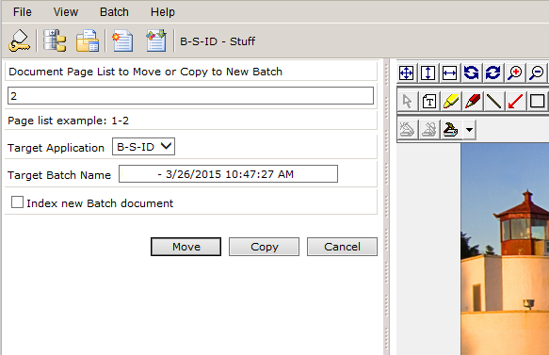

From here you can do the following:

1. Choose which pages to move or copy.
2. Choose to move the pages to a new BDM Application folder (not usually needed).
3. Type in the name of either a new batch, or the name of an existing batch. (Make sure you have the **exact** name of the existing batch that you want to move the pages to and paste the name in "Target Batch Name").
   1. If you want to switch to the new batch and begin indexing, check the "Index new Batch document" option. Otherwise you will remain in the original batch.

Finally, click either the "Move" or "Copy" buttons depending on what you want to do with these pages:

## Add Pages to a Batch

1. Open a batch.



1. Click the **Return to Batch Scanning** icon.



1. Chose to add pages by clicking the **New Page**, **Scan**, and **Append**. This will add new scanned pages to the end of the batch. You could also use the **Clipboard Paste** or **Import File** options.

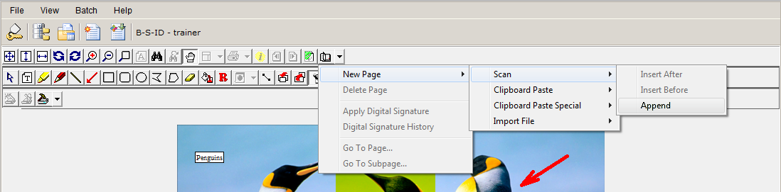

As an alternative, you could use the **Scan** icon.

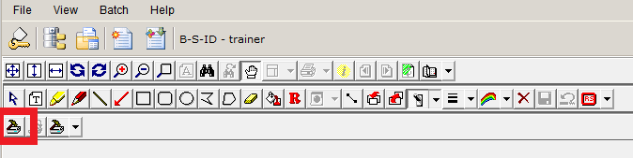

After scanning, return to the batch list and you can see there are now 3, instead of 2 documents for the batch.

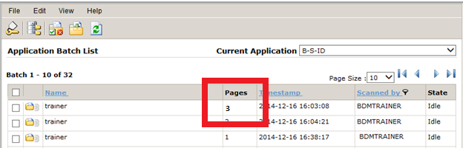

## Rotate Indexed Pages

When some of the pages of a document are scanned / saved in the wrong orientation, you can rotate the images and save as a new version. The original version will also be in the system too. The user must have “Enhance Pages” permissions in BDM for their application. Follow these steps for each pages that needs the orientation changed:

1. Open the document in BDM.
2. Use the **Rotate Left** or **Rotate Right** icons to correct the page orientation.

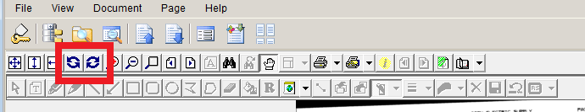

1. Click **New Page**, **New Version**, and **Current View** to save the updated document as a new page.

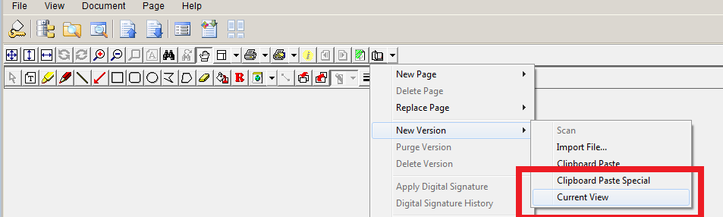

## Re-order Indexed Pages

Re-ordering indexed document pages in BDM can be done through either **Page Menu** option or the **Thumbnail View**. When the images are in a batch you cannot reorder pages. The batch should be indexed to a document, then re-ordered if needed. Users must have the “Add Page” permission in the BDM application to re-order pages in a document.

### Page Menu Option

Follow these steps to re-order pages:

1. Open the document in BDM.
2. From the menu, select **Page** and then **Reorder Pages**.
3. Choose one of the following options:
   1. **Move to First** – Moves the current page to the front of the document
   2. **Move Up** – Moves the current page up one position
   3. **Move Down** – Moves the current page down one position
   4. **Move to Last** – Move the current page to the end of the document
4. Close the document after you are finished moving pages. The changes are saved automatically.

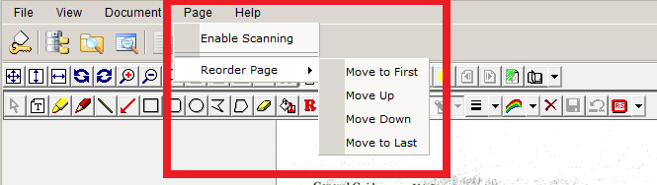

### Thumbnail View Option

Follow these steps to re-order pages:

1. Open the document in BDM.
2. Toggle the **Thumbnail View**.
3. Check the Reordering option.
4. Click on the individual thumbnails to drag them into the correct order.
5. Close the document after you are finished moving pages. The changes are saved automatically.

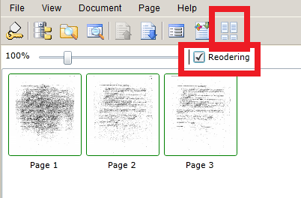

## Icons for Indexing Documents

|  |  |
| --- | --- |
| **Button** | **Description** |
|  | “Attach the current” displayed page to the current document. |
|  | “Attach all pages” remaining in the batch to the current document. |
|  | Modify index of current document |
|  | Select existing index information to populate index of current document |
|  | Clear existing index to enter new data |
|  | Access online help |

# Document Query and Retrieval

Each time a document is added to AppXtender Web Access, index information is added to identify the document. This index information is also used for document retrieval.

## Begin a Query

To retrieve documents, right click on the Application (File cabinet) you want to select documents from the click **New Query**.

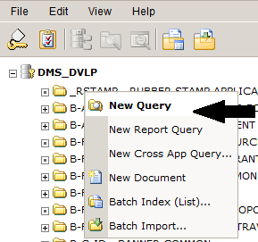

## Enter Query

A screen containing the index fields for the application will appear.

1. Enter the data values in the appropriate fields.
2. Click **Submit** in the bottom right corner to execute the query without saving it.

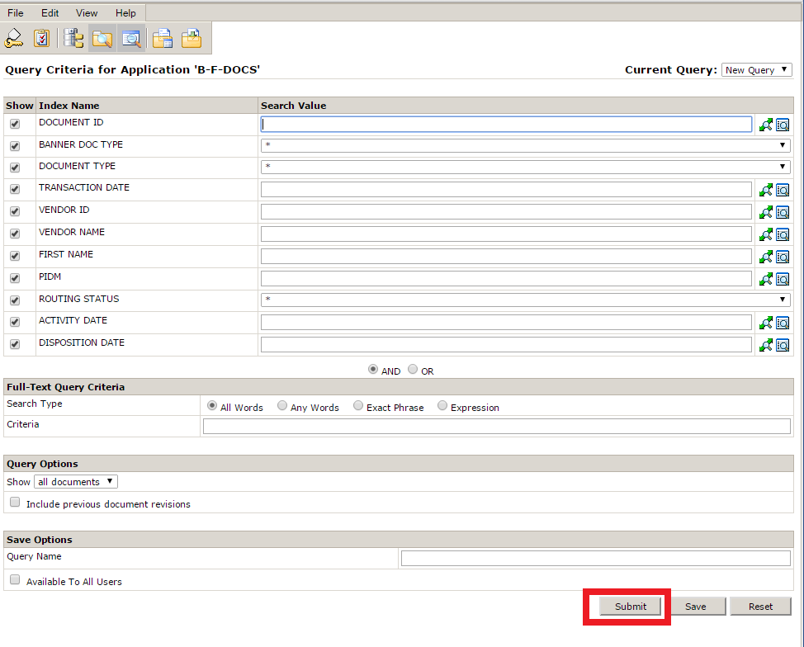

## New Query Toolbar Icons



|  |  |
| --- | --- |
| **Button** | **Description** |
|  | Logoff (Always logoff before closing your window) |
|  | View/Modify Settings |
|  | Application List |
|  | New Query |
|  | Query Results |
|  | Access Batch List |
|  | Batch Import View |
|  | View Current Document |

## View Results

Results may look similar to those shown below in **Query Results** set: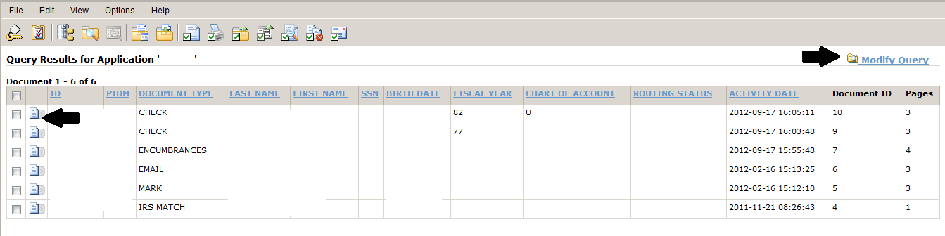

The following options are available:

1. Open a document: click on the paper icon to the left of a document.
2. Modify the query: for a new set of results, click on the “Modify Query” option in the top right corner.

## Advanced Queries

In addition to basic searches on index field values, you can perform wildcard and list of values searches. Wildcard searches are useful if you have a broad range of values to search for or if you only know part of an index field value that you want to look for. A list of values search is useful if you have a specific set of values that you want to search for exclusively.

### Wildcard searches:

BDM uses the asterisk (*) as the wildcard character. A wildcard character can be used at the beginning, end, or middle of a search value. In the example below, all IDs beginning with 905 would be part of the search criteria. 

If you had an index of Vendor Name and you wanted to see all documents for vendors that had “City” in their name, you could enter “*City*” as the search value for the Vendor Name index field. If you wanted to find all vendors that had a “Johnson” and “City” in the name, you could enter “*Johnson*City*”.

### List of Values Search

Click the far right magnifying glass to open the Search List Editor that will allow you to add specific values to search on.

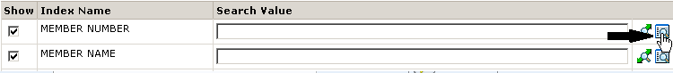

The Search List Editor Appears:

.

Follow these steps to add search values:

1. In the Field Value text box, Enter a value in the “Field Value” for the list
2. Click “Add” to add the value to the list.



1. Click Ok. The list of values editor closes, and the specified criteria appears in the appropriate text box on the search criteria page.



## Icons for Query Results



|  |  |
| --- | --- |
| **Button** | **Description** |
|  | Logoff (Always logoff before closing your window) |
|  | View/Modify Settings |
|  | Application List |
|  | New Query |
|  | Query Results |
|  | Access Batch List |
|  | Batch Import View |
|  | Open selected documents from result set |
|  | Print selected documents from result set |
|  | Export selected COLD documents from result set |
|  | Export selected document indexes |
|  | Text search selected documents |
|  | Delete selected documents |
|  | Email selected document |

**NOTES:**

* If no documents are available for the criteria, the message “No Documents Found” is displayed.
* If there is only one document retrieved for the input criteria, you may configure your browser to open the document by default in the workstation configuration settings. See System Setup.
* To return to query results, go to **View** then **Query Results** as shown below.
* To start a new query, go to **View** then **New Query** as shown below.

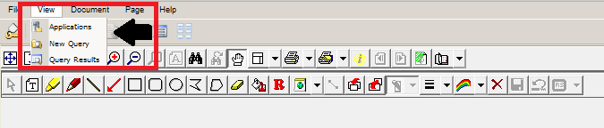

# System Setup

**Important Notes before You Begin:**

* You may need to configure your workstation. Visit <https://www.etsu.edu/banner/bdm> for instructions.
* The components are specific to a computer. If you get a new computer or use someone else's computer, you may have to install the components.
* When upgrades to BDM are installed, new components may need to be installed.
* If an older version of a component is already installed, you may need to uninstall the older version before you will be able to install the new version.
* During usage of BDM, you may also be prompted to execute a "cab" file.
* **When scanning, you may be prompted to install WxScan.cab, please do so.**
* **When viewing, you may be prompted to install both the IrcView.cab and the IrcResultSet.cab**

## AppXtender User Settings

### Manage Interactive Viewer

To scan from BDM via AppXtender, you will need to enable the Interactive Viewer.  This will need to be done once.  Your account will save your settings.

1. Navigate to the **Application List** (Click the **Spine** icon, third from the **Key** icon).

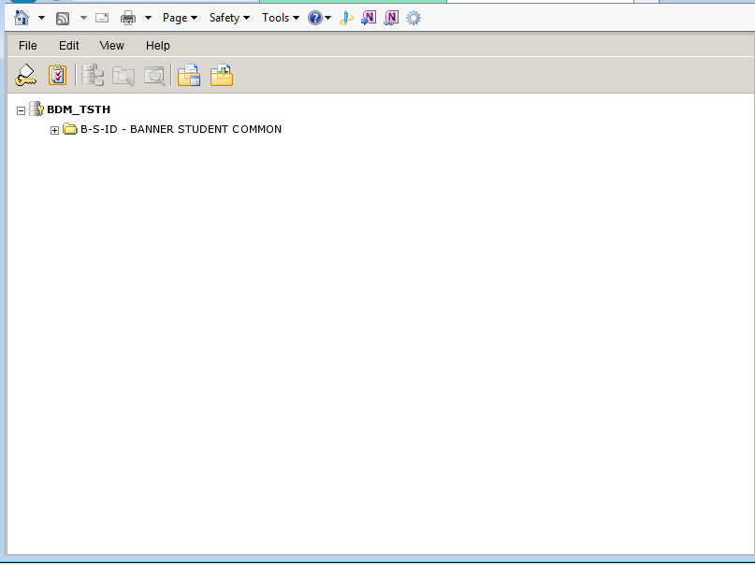

1. Click the **Edit** Menu Item and select **User Settings**.

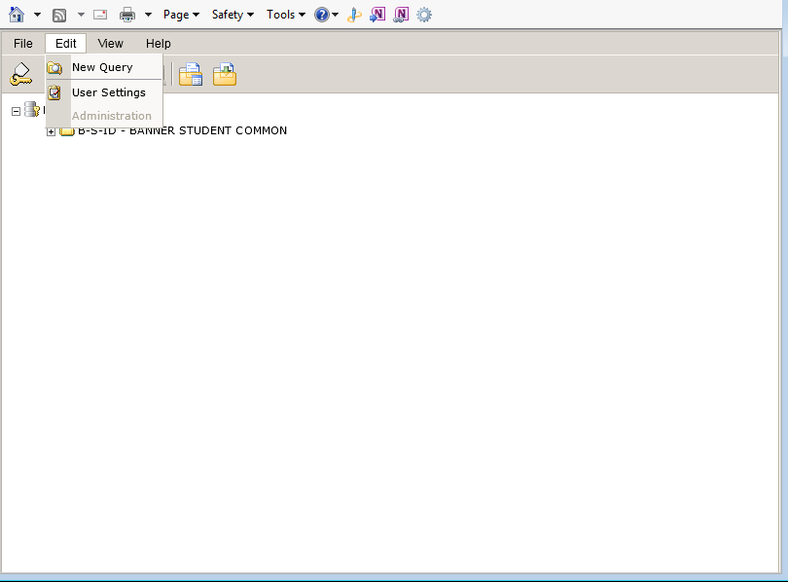

1. Click the fourth tab down for **Interactive Viewer**.  Then check the first check-box for **Enable Interactive Viewer**.

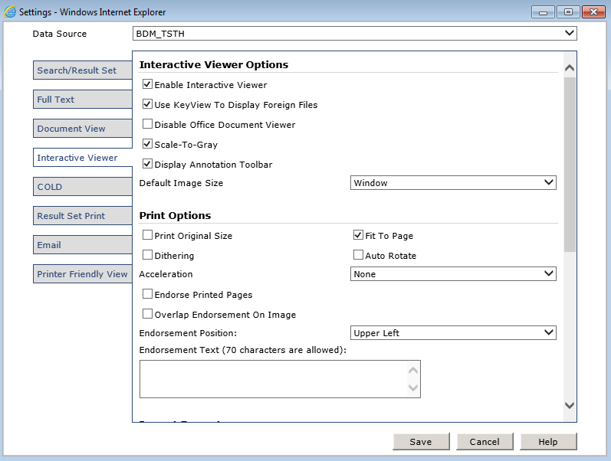

1. Click the **Save** button.

### Mange Document View Settings

If you want to view thumbnail previews of all pages when you select a document, follow these steps:

1. Click **Edit** then **User Settings** to openthe Settings window.
2. Click the **Document View** tab. Check **Show Page Thumbnails**.
3. Click the **Save** button.

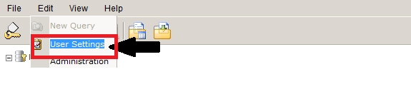

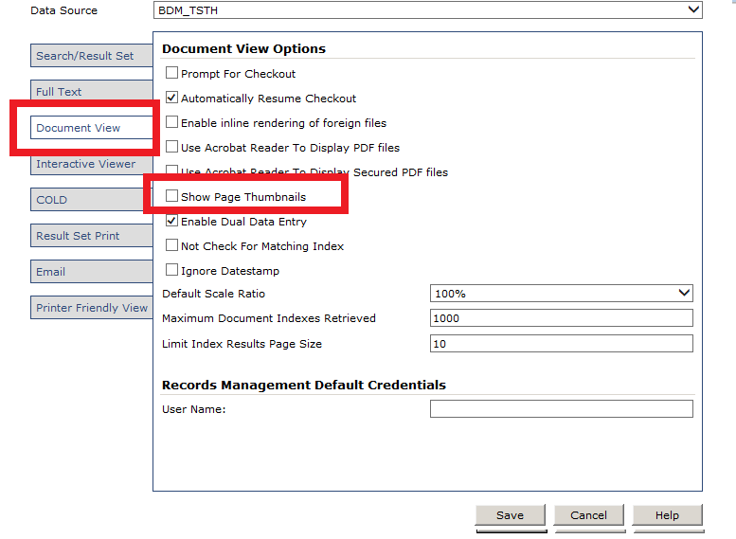

### Manage Search / Result Settings

1. Click the **Search/Result Set** tab. Check **Automatically open document if query yields one result**.

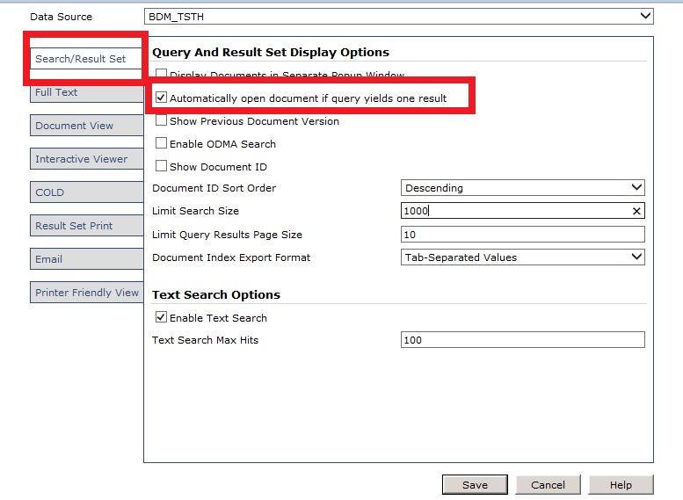

1. Change **Limit Search Size** or **Limit Query Results Page Size** based on your preferences.

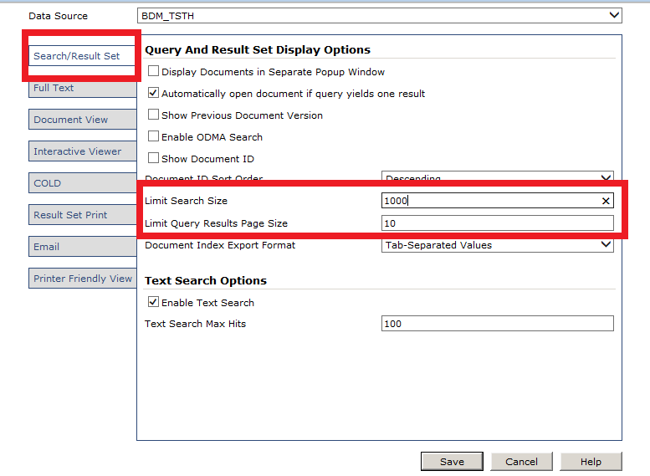

1. Click the **Save** button.

## Internet Explorer Setup

These steps need to be completed  **once**  on each computer where users will access BDM.  The user performing these steps must be an  **administrator**  of the computer in question.  That is, they must have rights to install software.  If you do not have rights to install software on the computer, please contact the OIT Help Desk for assistance.

**Required Internet Explorer Setup**

In order to successfully scan documents via BDM, the following settings in Internet Explorer must be made for *each* user on the computer to be used.  This only needs to be completed **once per user per computer**.

1. Select the gear icon in the upper right corner of the Internet Explorer window to bring up the menu.  Select **Internet Options**.

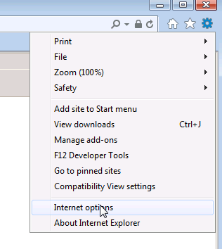

1. Select the **Security** tab from the **Internet Options** dialog.

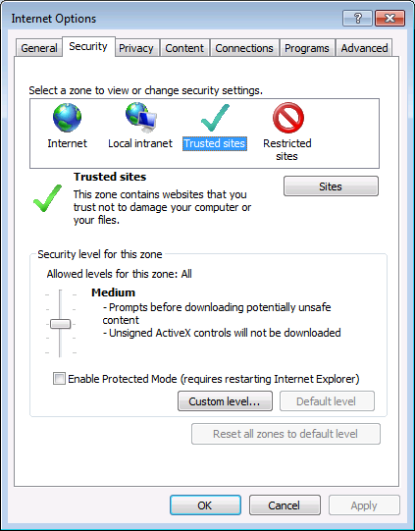

1. From the **Security** tab, select the **Trusted Sites** icon and click the **Sites** button to open up the list of trusted sites.

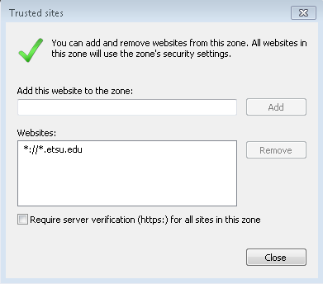

1. Within the **Trusted Sites** dialong, enter **\*://*.etsu.edu** and click Add to add it to the list.  Click **Close** when done.
2. Select the **Privacy** tab from within the **Internet Options** dialog.  Under the **Pop-Up Blocker** heading, click **Settings**.

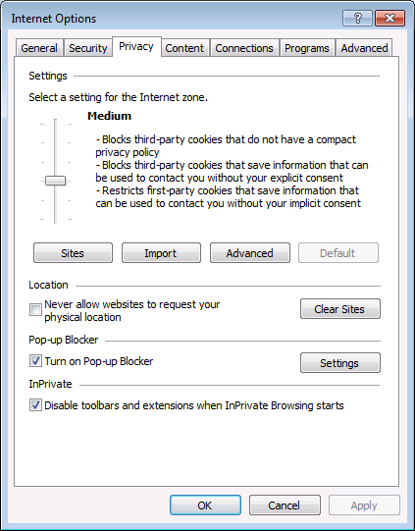

1. In the **Pop-Up Blocker Settings** dialog, enter the address **banner.etsu.edu** and click **Add** to add the site to the list.  Click **Close** when done.

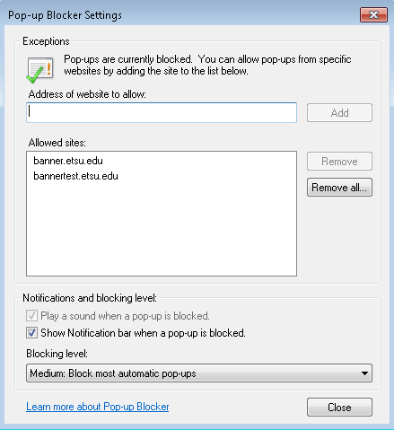

1. Click **OK** from within the **Internet Options** dialog.

## Scanning Components

1. Log into BDM using Internet Explorer via INB by clicking on the magnifying glass or plus sign.  You will see a list of "applications" which you have access to in BDM.

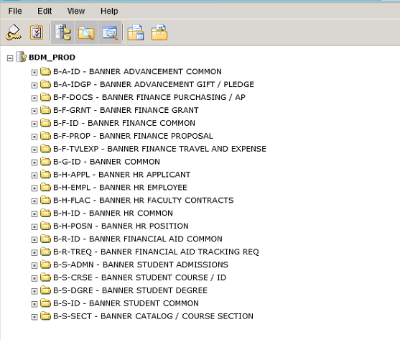

1. From the **Help** menu, select **Check Installed Components**.  A dialog box will appear showing the EMC plug-ins that need to be installed.

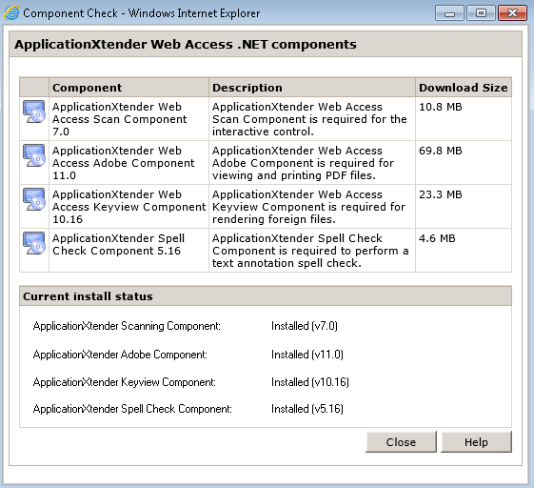

1. Select the icon to the left of the first component, **AppXtender Web Access Scan Component**.  Click the **Run** button when prompted by the browser.

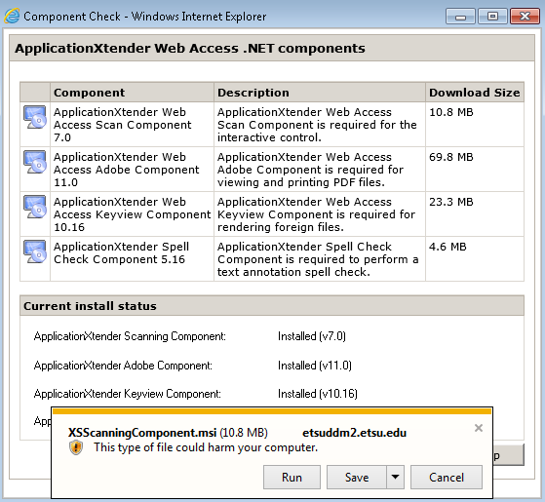

1. The installation wizard for the component will start.  Click the **Next** button.

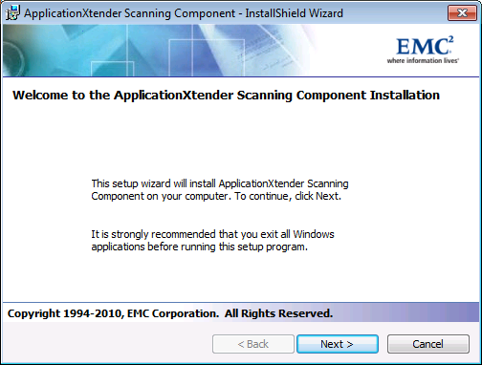

1. Select **I accept the terms of the license agreement** and then click the **Next** button.

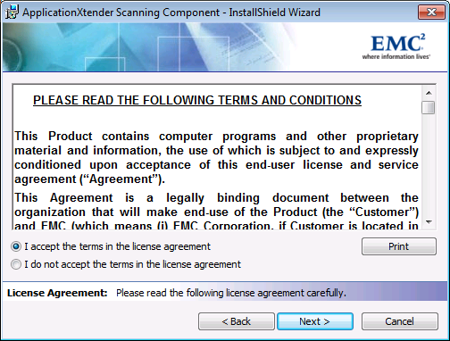

1. Select **Anyone who uses this computer (all users)** and then click the **Next** button.

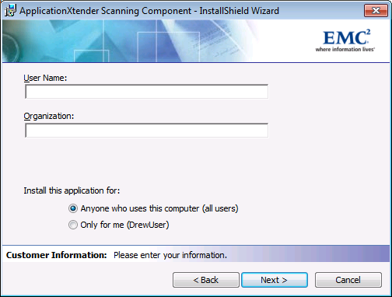

1. Click **Install** to begin the installation process.

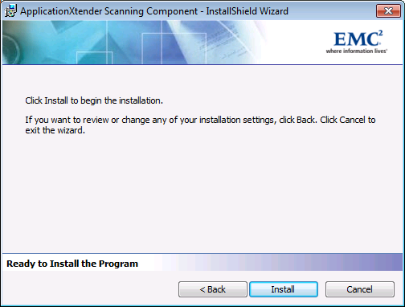

1. If you are prompted by your computer, click **Yes** to allow the plugin to be installed.  If you are instead prompted for an Administrator username and password, please contact the OIT Help Desk.  This means the account you are using to log into Windows on the computer does not have Administrator rights.

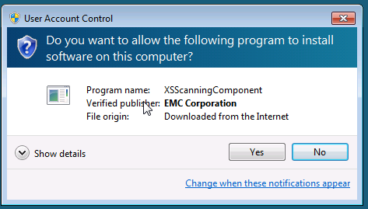

1. Once the installation of the first plug-in is complete, repeat steps 4-8 for the remaining three EMC components that need to be installed.

