eBucs Email Approval
Approvers can approve eBucs requisitions from within the email notification. This feature can be used on mobile devices such as smart phones and iPads. It can also be used on personal computers. Please note this is just an alternative way to approve, you may still approve within the eBucs site.
When you approve a requisition from within the email notification, you will be asked to enter your personal email approval code. Follow the steps below to set up your code:
- Sign into the eBucs site
- Go to View My Profile by clicking your name on the top right (see A in screenshot below)
- Your User Profile will now show
- In the left column select Update Security Settings > Change Email Approval Code (see B in screenshot below)
- A box will appear and you will enter a code with at least four digits.
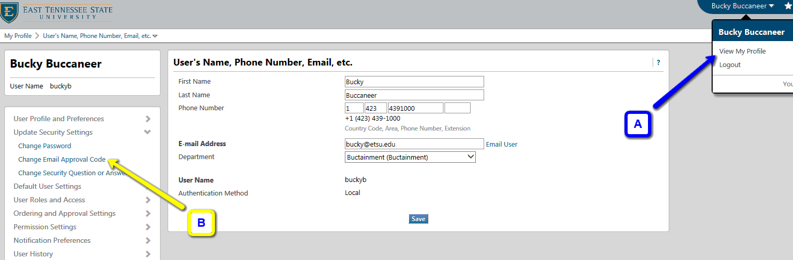
- Click ‘Save Changes’

