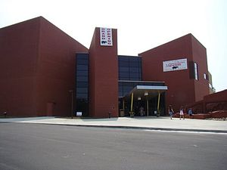
The Gray Fossil Site and Museum
1212 Suncrest Drive
Johnson City, TN 37616
(423)439-3659 or
1(866)202-6223
The museum is located on Highway 75
approximately 1.8 miles from the Gray, Tennessee Interstate 26.

For driving directions please click link below.
https://www.randmcnally.com
2015 ETSU STEM Conference

 | Registration Form
Registration Fee is $75.00
*(Please mail check to me by May 15, 2015 or pay online at https://epay.goldlink.etsu.edu/C20071_ustores/web/store_main.jsp?STOREID=64&SINGLESTORE=true ) Payable to the “ETSU STEM Conference”
Thursday, May 28th and Friday, May 29th, 2015
Name:
Title:
Place of Employment:
Address:
City:
State:
Zip:
Phone:
Phone:
Email:
Date (s) for room reservations at the Carnegie Hotel | Tel. 888-854-8215
 | Please contact the Carnegie Hotel for reservations. Let them know that you are with the ETSU STEM Conference so you can receive the state rate of $92.00 per night + local & state taxes.
Special needs:(DIETARY)
Ms. Angela Haga
Executive Secretary, Center of Excellence in Mathematics and Science Education
http://www.etsu.edu/cas/math/mathexcellence/default.aspx
Assistant Director, Governor's School for Scientific Models and Data Analysis
http://www.etsu.edu/cas/math/mathexcellence/govschool/default.aspx
Public Relations Coordinator, ETSU Northeast Tennessee STEM Innovation Hub
http://www.netstemhub.com
East Tennessee State University
P.O. Box 70301
509 Warf-Pickel Hall
Johnson City, TN 37614-1709
 (423)-439-7592  (423)-439-7530 haga@etsu.edu

