BUC BIKES
Weekly and Monthly
Bike Rental
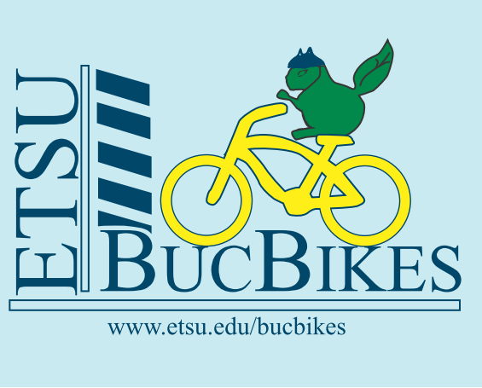

Campus Recreation has multi speed bikes, available to rent on a weekly ($5) or monthly ($15) basis.

Step 1: Complete the on-line bike safety quiz found here; https://healthsafety.etsu.edu/index/login
- Log in using your ETSU e-mail and password
- In the left column select “Training Modules”
- Select “Bicycle Safety” under Modules you can take
- Take a few moments to review the information. Take the quiz, and…
- Print the certificate and KEEP IT – you will need it to rent a bike.
Step 2:
- Stop by the Member Services Desk at the Basler Center to fill out the Rental Agreement. You will be contacted by a Buc Bike staff to schedule orientation, fitting and pick up your bike.

This is a RIDE AT YOUR OWN RISK service. Before you can check-out a “Buc Bike” you must read, agree to and sign the Buc Bikes Rental Agreement at the CPA.

Users are responsible for replacement fees for damaged or unreturned bikes/accessories and late fees, a hold will be placed on student accounts for any overdue fees. Please see Rental Agreement for fees.

General Safety Guidelines
- Abide by all local and state traffic laws.
- Check the bike for safe operation before using.
- Wear a helmet.
For more information:
www.etsu.edu/students/campusrec/equipment/bike.aspx
Or to contact us:
BUCBIKES@mail.etsu.edu

