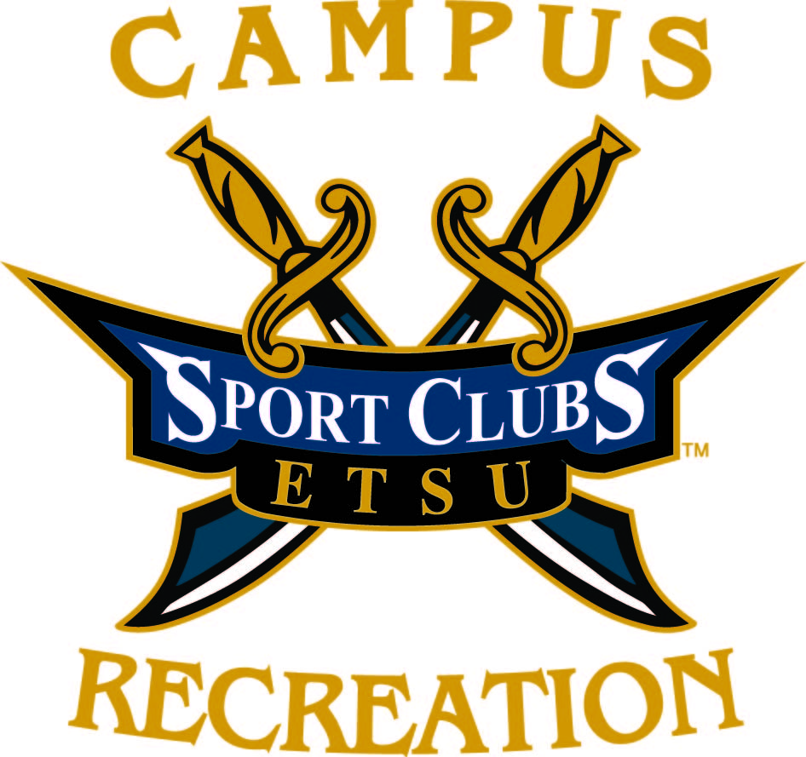
ETSU Campus Recreation

Application for Sport Club Charter
This form should be completed by clubs wishing to be granted a charter as an ETSU Campus Recreation Sport Club. All prospective clubs must be registered as a student organization with the Student Organization Resource Center (SORC) before their application will be considered.

Chartering Information
- Temporary Charter Guidelines includes expectations and responsibilities of Temporary Charter Clubs.
- In order to be granted a Temporary Charter, a club must have a hearing as outlined in the Sport Club Handbook.

Proposed Club Information
Sport Club Name
National/Regional Conference or League |  |  |  |  | Local/Regional Clubs that this club will compete against
Current Practice Times: |  |  |  |  | Current Practice Locations:
Stated goals and objectives:
Elected Club Officer Information
President  Name |  |  |  | Vice President  Name
Email |  |  |  | Email
Phone |  |  |  | Phone
Graduation Date |  |  |  | Graduation Date
Secretary  Name |  |  |  | Treasurer  Name
Email |  |  |  | Email
Phone |  |  |  | Phone
Graduation Date |  |  |  | Graduation Date
When are club elections held?
Club Support Information
Club Advisor  (Must be current faculty or staff) |  |  |  |  |  | Coach
Email |  |  |  |  |  | Email
Phone |  |  |  |  |  | Phone

(More information on next page)
Membership
- All club sports are required to have a minimum of 10 active dues-paying members.
  - For team sports, clubs are required to have 10 members or 150% of the number of players it takes to field a team for that sport, whichever is greater. For example:
    - Club Basketball requires 10 members (150% of 5 = 7.5, rounded to the next whole number is 8; 10 > 8)
    - Club Soccer requires 17 members (150% of 11 = 16.5, rounded to the next whole number is 17; 10 < 17)
- Please list all active members in the Club:
Member Name Email Address E-Number

Submit this application and a copy of the club’s constitution the Campus Recreation Administrative Office, 2nd floor BCPA

For more information, contact the Sport Club Graduate Assistant at 423-439-7987 or SportClubs@etsu.edu.

The Sport Club Executive Board reserves the right to refuse a temporary charter form if consensus is reached that the necessary resources (facilities, administrative, and financial) are not available.

Attachments with club materials, league information, and additional members are encouraged.

