# Guide for watching videos on KBport system with KbPort Browser.

On a windows computer that you have admin rights on (able to install software)

Download and install the custom ETC KbPort browser from

<https://kbport.com/downloads/>

*Windows may try to prevent installation with the “Windows has protected your PC” pop up.   If this happens, just click the “more info” link on that pop up and then the “Run Anyway” that appears at the bottom.

If you are not an administrator on your computer, you can call 439-4648 and ask the helpdesk to help you get it installed.

After you have installed the ETCBrowser:

1. Open the ETC browser
2. Type in the address bar at the top workflow.etsu.edu *if the browser says the site is unsafe, click the advanced options on the warning and then proceed to site anyway*
3. Enter your ETSU username and password. *you must be granted permission for access*

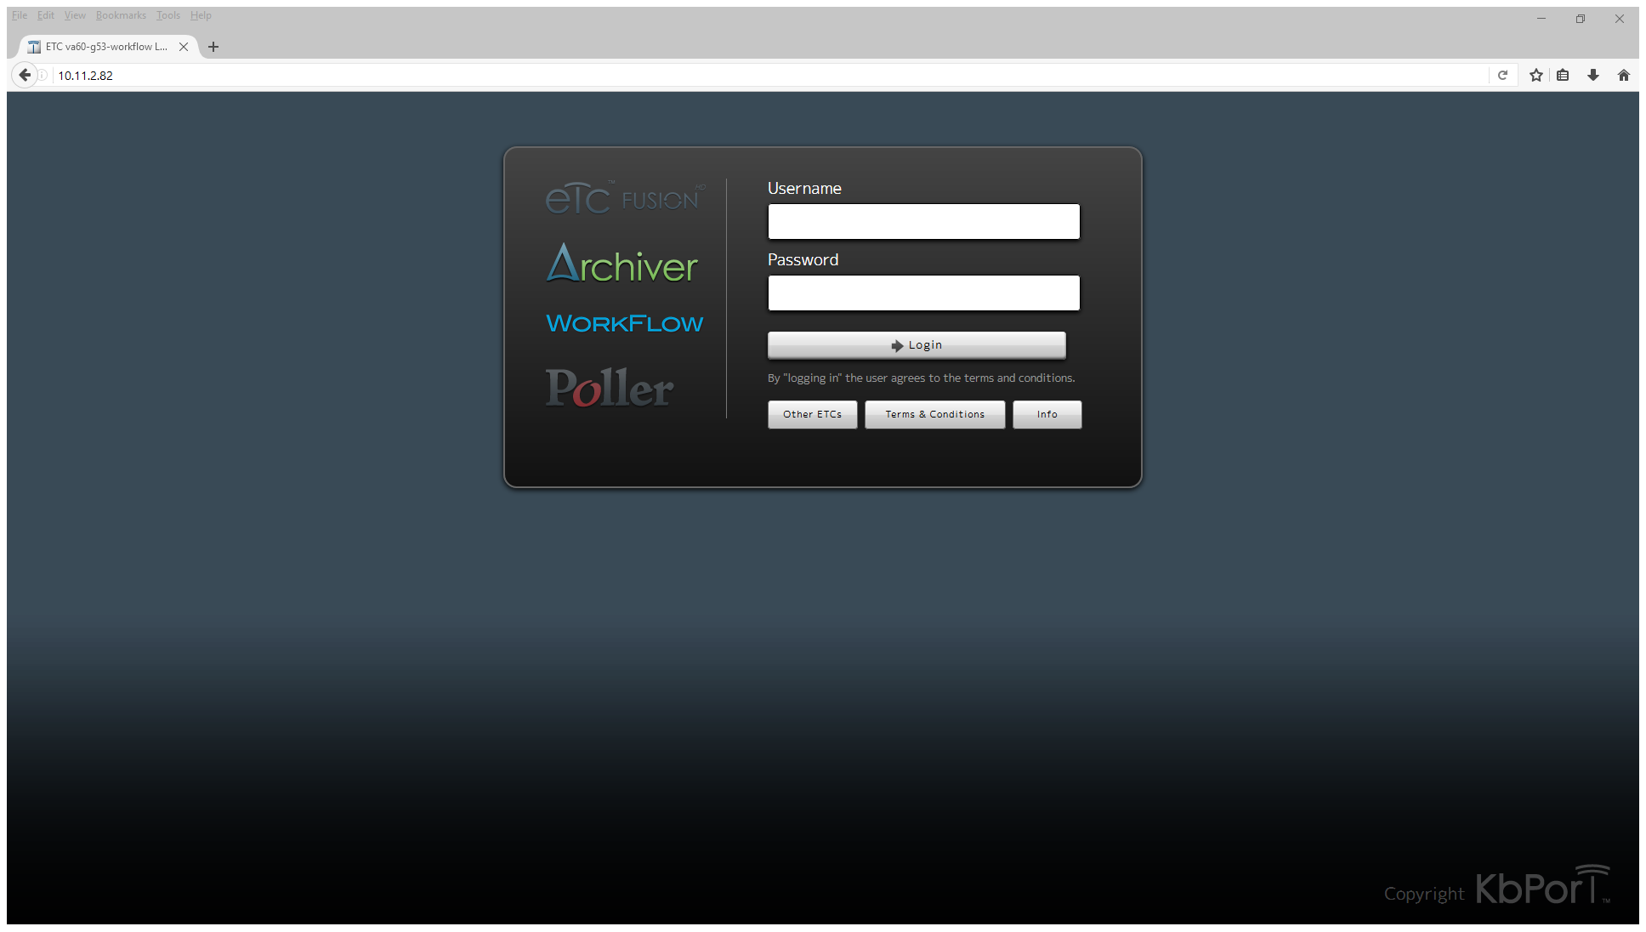

1. After you have entered your username and password you should be taken to the main Archiver interface as follows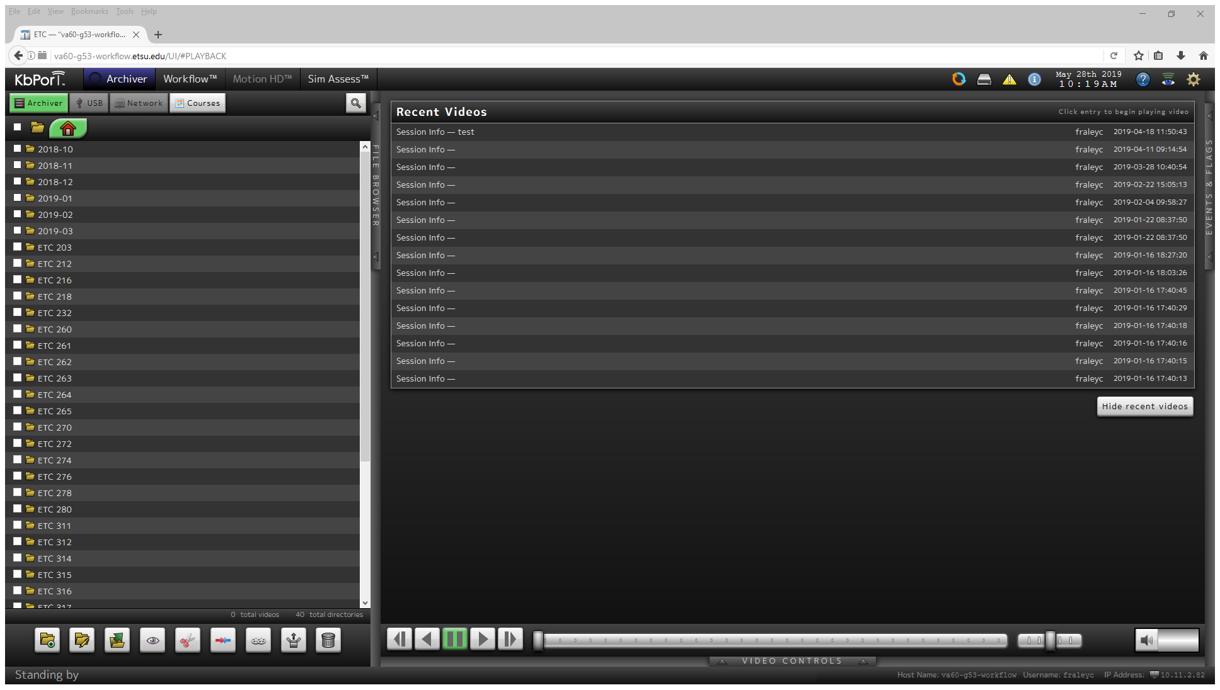
2. The folders are listed by months, then room number, select your room number.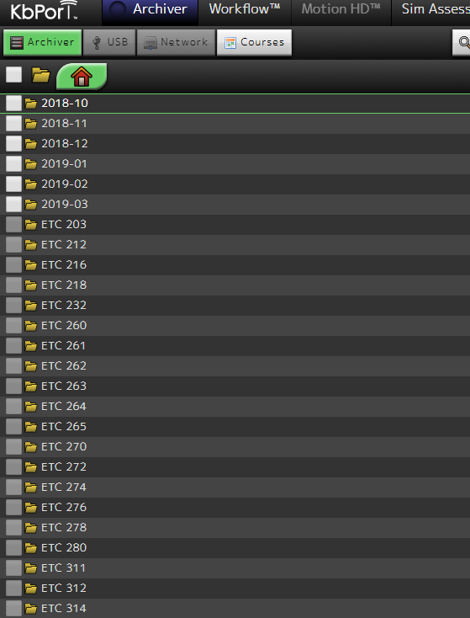
3. Under the room number select your month and year of recording.

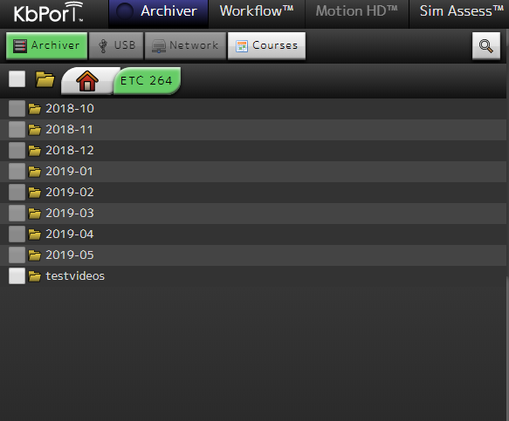

1. Then select by date and time.

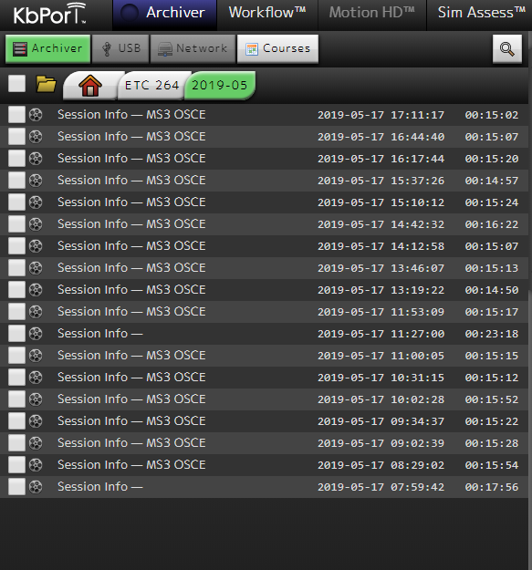

1. You can also hit the search button and sort by student name, but this is a very basic search and can bring up multiple sessions, students or default to last played video if it encounters an error. Caution is advised when using the search function. Knowing the room number and date are more precise. *the search function is VERY specific, if anything is misspelled or incomplete it will not find it.

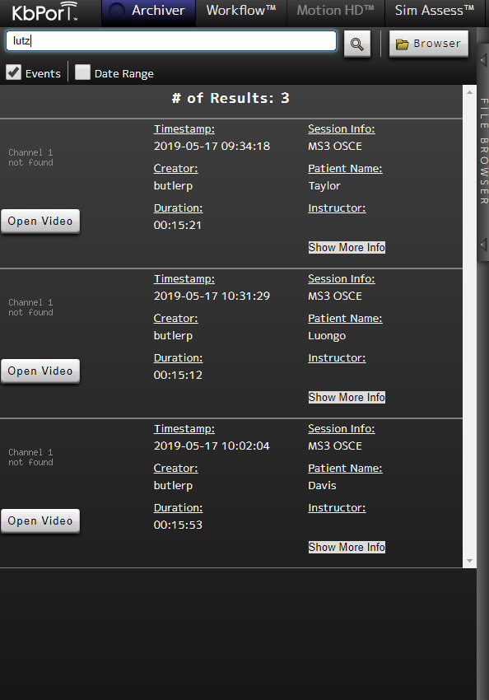

1. Once a file has been selected in the folder view, the video will play with standard controls on the right hand pane.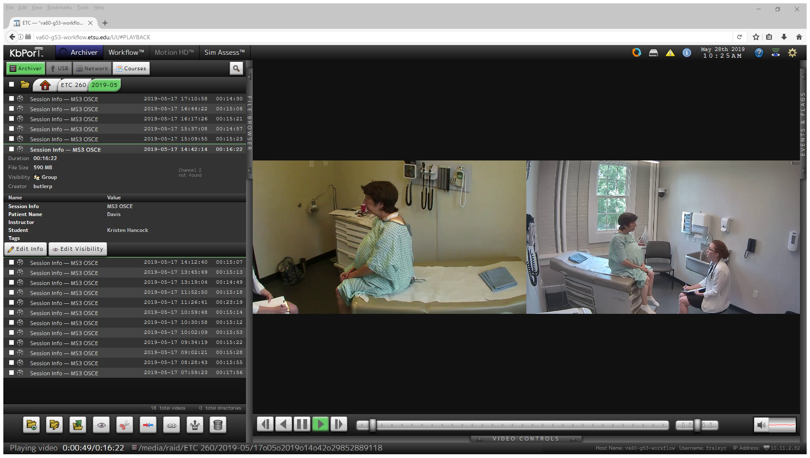
2. To return to the master folder list, click the house shaped icon tab at the top of the folder view window, or to return to the particular ETC room server hit the ETC (room number) tab.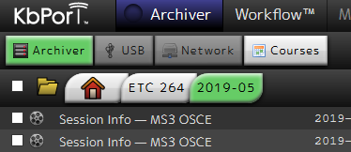

If you have any questions or issues please email Chad Fraley at [fraleyc@etsu.edu](mailto:fraleyc@etsu.edu) or call 439-8101