IPERC BOOKING CALENDAR INSTRUCTIONS

- You can access the calendar at https://iperc.bookedscheduler.com.

- Faculty and Staff of ETSU can log in with their ETSU credentials.
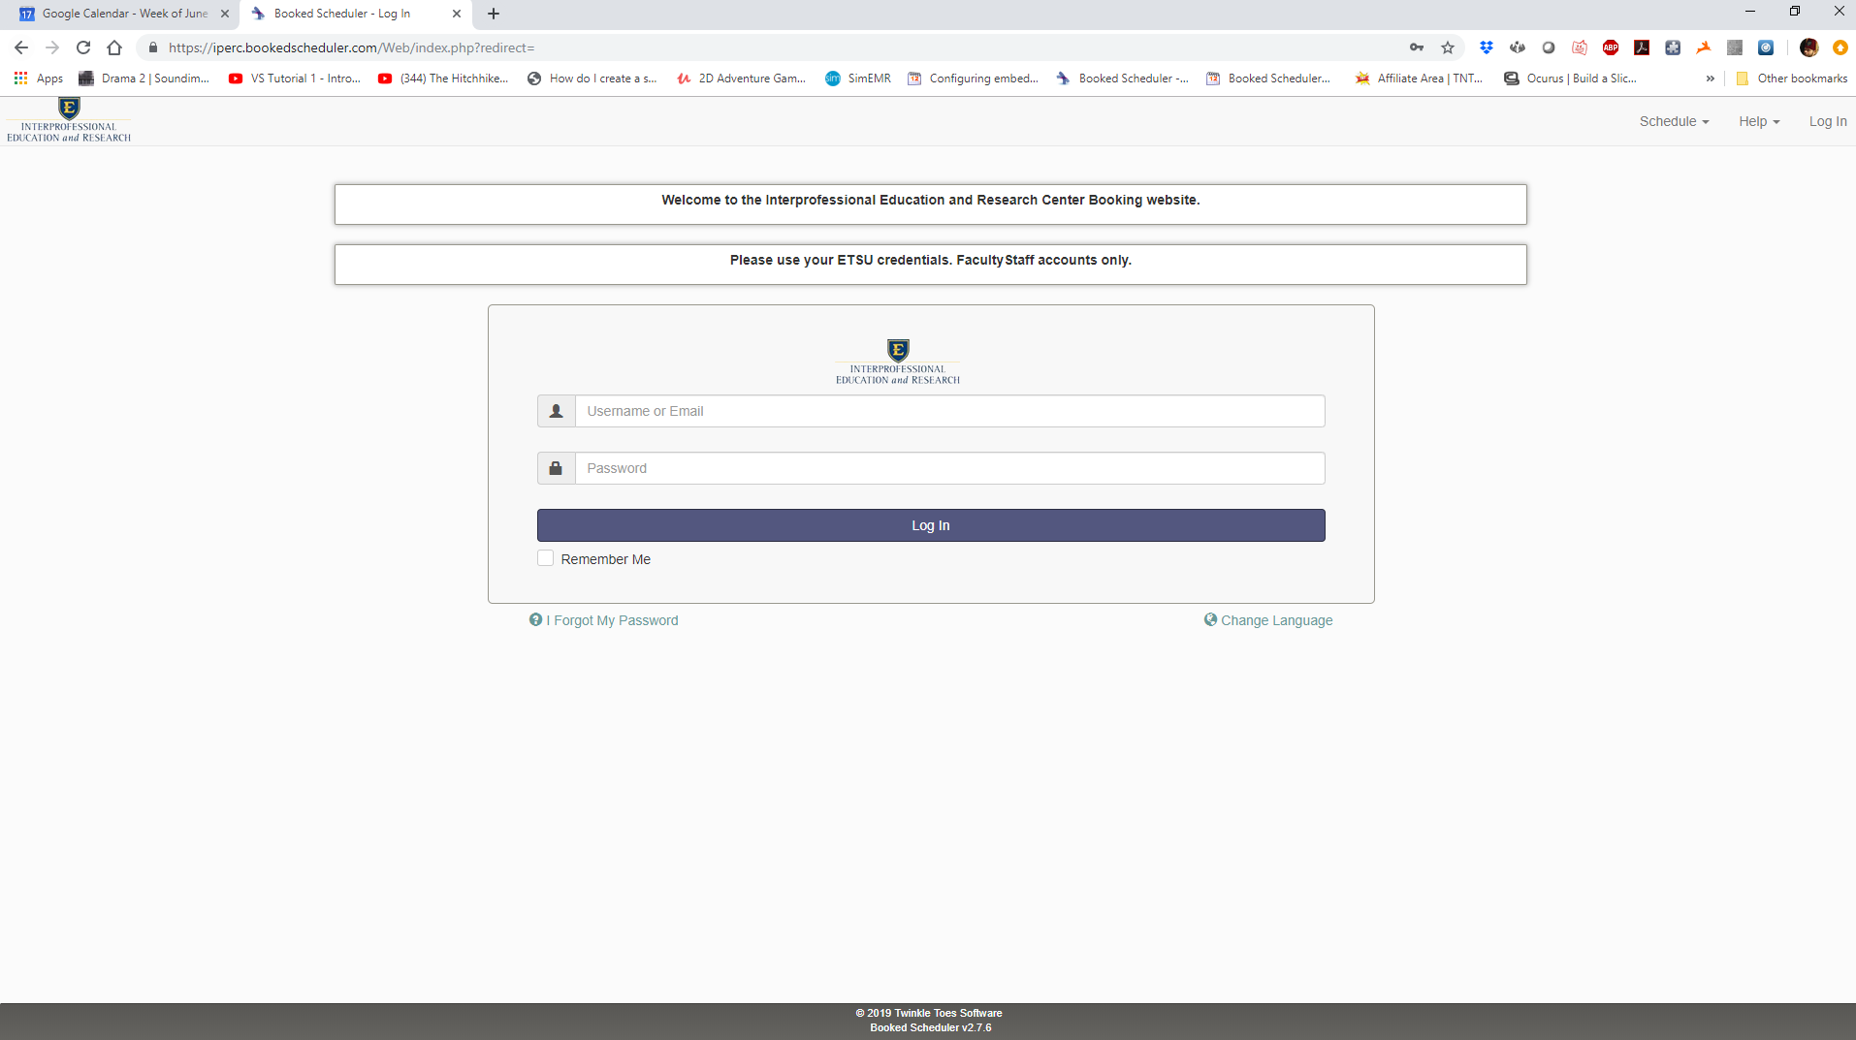

- After logging in, you will see your Dashboard (you can return to this view by hitting Dashboard in the top menu).
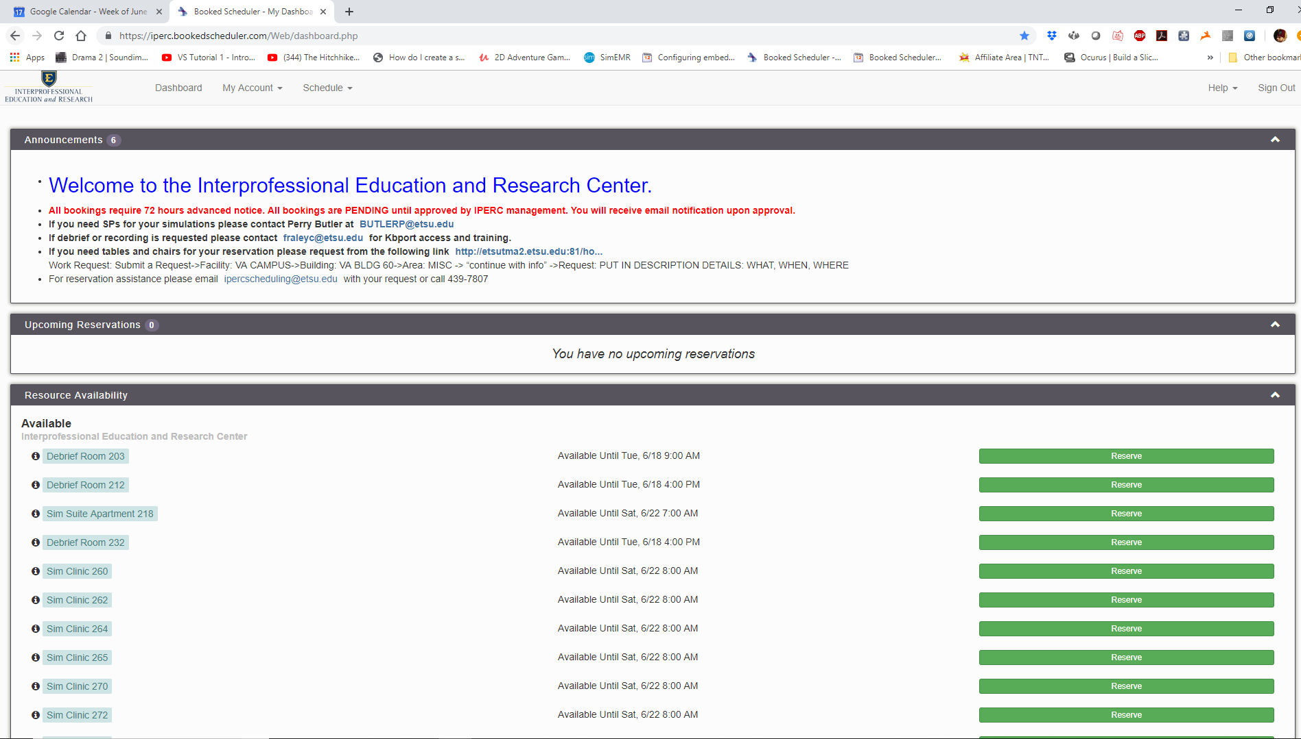
- Please read all Announcements in the Announcement box located at the top of the page.

- If you have upcoming reservations, they will be listed in the Upcoming Reservations box.

- All available rooms are listed in the Resource Availability box. You may reserve a room, or block of rooms, by clicking on the green Reserve button to the right of the appropriate room.

- If you hover over the black circle with the letter “i”, you will get a pop up that lists the room, available equipment, a photo of the room and, if applicable, the number of participants that can be seated in that room.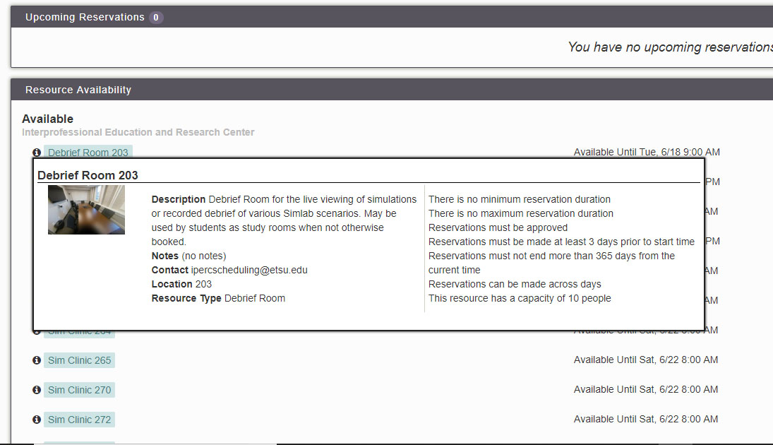

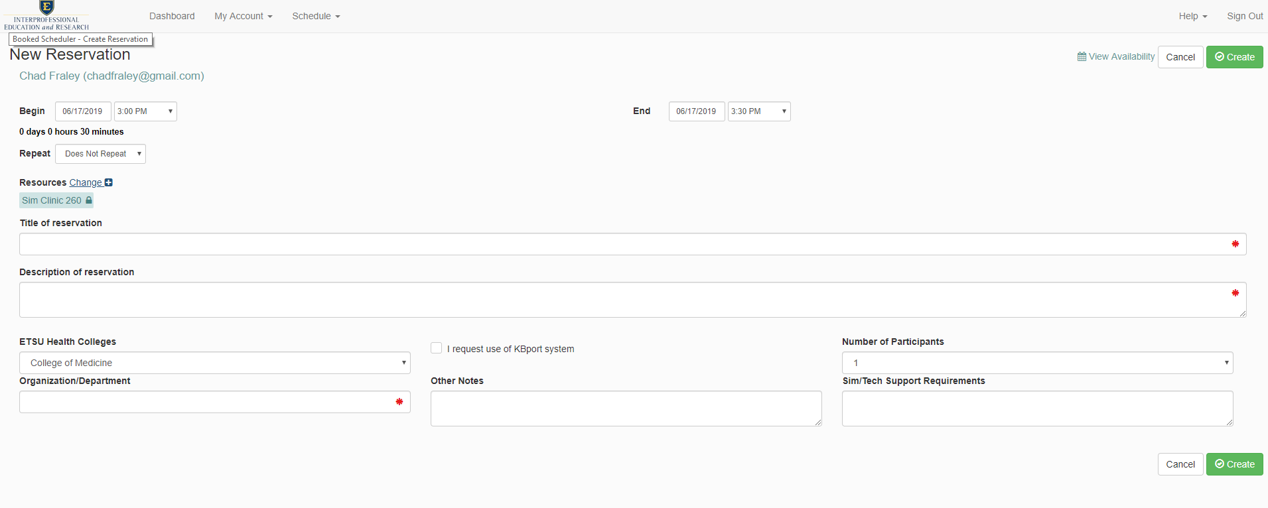
- In the following example, clinic room 260 has been selected. Once the reserve button has been clicked, you will see the screen below. You can select Begin and End date and time, Repetition, Title your reservation, supply a Description of the event, and indicate your Organization/Department. Anything marked with a red * is required and must be filled out. If you plan on using the KBport system to monitor or record your event, please check the “I request use of KBport system” radio button. If you require special Sim/Tech needs, please describe them in the “Sim/Tech Support Requirements” field. The “Other Notes” is for any information you feel may be needed that is not appropriate for other fields.
- If you need multiple rooms for your event, hit the reserve button on the Dashboard view for one of the room you need (260 in the above example) then in the reservation page click “Change +” next to the Resources heading.
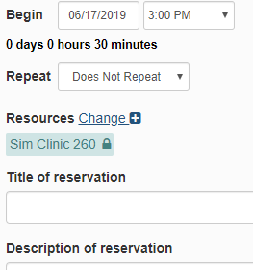

- Once the “Change +” has been clicked, you will see a popup window with all rooms and their associated radio buttons. Simply click on the individual rooms you also wish to reserve, or the head radio button in the case that you wish to reserve all rooms in the group (all sim clinic rooms, for example). After you have selected your rooms, hit done. All rooms should now be added under one reservation. *Any room in red with a strike through it is not available during the chosen time and day.*
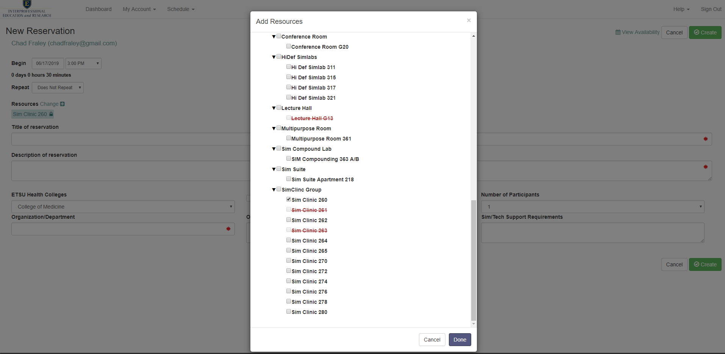
- Here you can see we have filled out the forms and added multiple sim clinic rooms for our event.
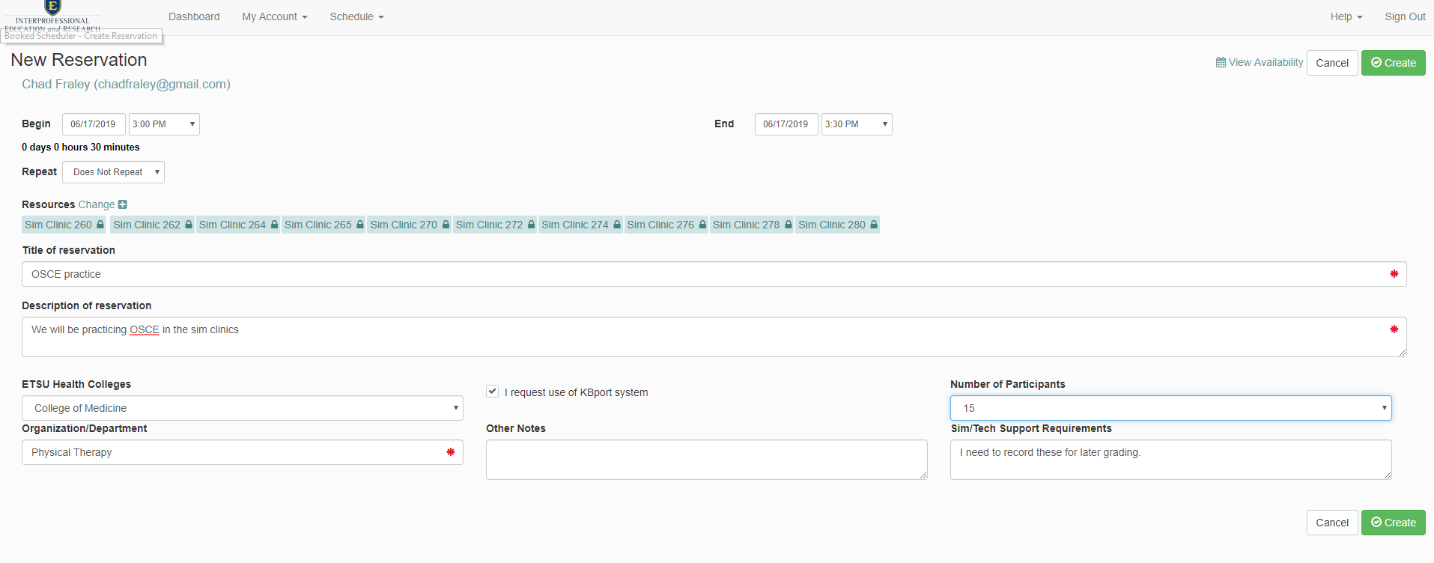
- When you have reviewed your form and are satisfied, hit the create button to schedule the selected rooms. After a few seconds, a window will let you know the status of the reservation. All reservations are pending until approved by IPERC Staff. You will receive email notification when initially reserving and when approved.

VIEWING THE SCHEDULE CALENDAR

- To view all upcoming reservations and room availability, click the Schedule pulldown menu at the top of the page.
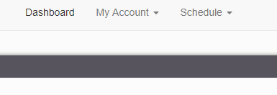
- In the pulldown menu under Schedule, select “Bookings” and you will be taken to a sortable calendar of all upcoming events. You can scroll to the top of the page to select date ranges to view.
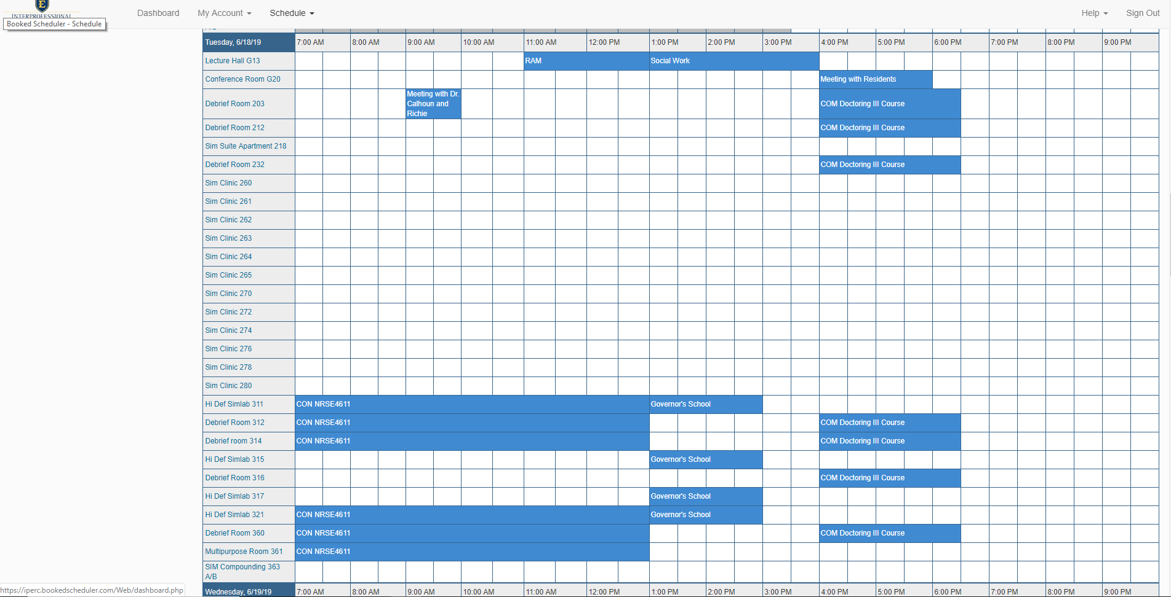

- You may also book reservations from this “Bookings” view by using your curser to select a block of time and room on the appropriate date. This brings up the Reservation window as exampled above.

VIEWING YOUR SCHEDULED CALENDAR

- Other Options in the Schedule pulldown are “My Calendar” which shows a calendar view of all of your reservations, “Resource Calendar” which is a calendar view of all reservations, and search tools to help “Find a Time” a room is available and “Search Reservations” to find specific reservations through various filters.

If you have any questions about the calendar please contact within your College:
College of Clinical and Rehabilitative Health Sciences - Kristen McHenry MCHENRY@mail.etsu.edu
College of Medicine - Jake Drumm DRUMM@mail.etsu.edu
College of Nursing - Mark Bodo BODOMN@mail.etsu.edu
College of Pharmacy - Daniel Vanzant VANZANTD@mail.etsu.edu
College of Public Health - Allan Forsman FORSMAN@mail.etsu.edu

For general questions, please contact IPERC IT Coordinator Chad Fraley fraleyc@mail.etsu.edu.

