To access eBucs through GoldLink:

**Your password for signing into eBucs via GoldLink will be your ETSU network password (the same password you use to sign into your computer). If you have difficulty signing in with your network password, please contact the ETSU** [**ITS Helpdesk**](mailto:itshelp@etsu.edu?Subject=) **.**

1. Click **Goldlink** on the ETSU homepage:

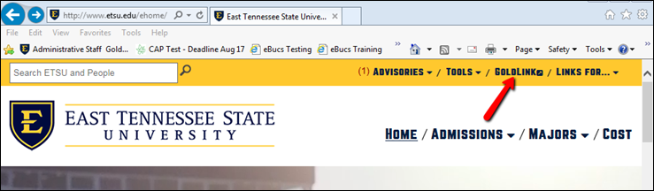

1. Sign in to Goldlink with your **username** and **password** (the same you use to sign into your computer):

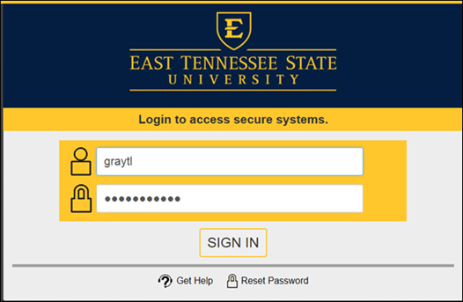

1. Once signed in, click **Administrative Staff** on the left side of the screen:

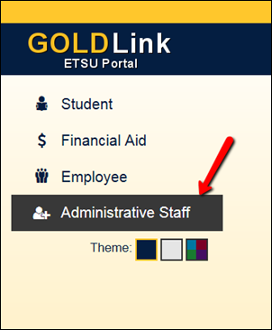

1. Click and expand the **Administrative Tools** box and you will see a link for **eBucs**:

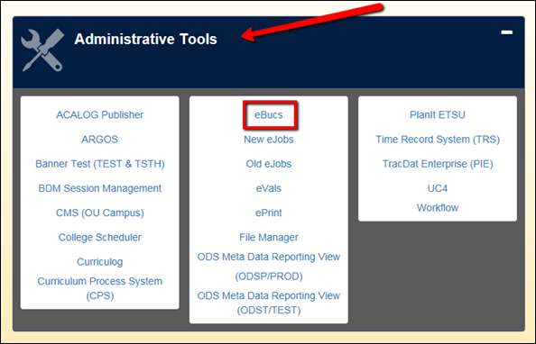

**Alternative access to eBucs:**

1. If you do not have the Administrative Staff button in GoldLink, you will need to go to our website to login to eBucs:

[www.etsu.edu/procurement](http://www.etsu.edu/procurement)

1. Click **eBucs** from the navigation menu on the left and enter your network **username** and **password**:

