Student Name:______________________________ Major Advisor __________________________________
ID Number:________________________________ SETP Advisor __________________________________
Catalog Year: 2022-2023
SECONDARY EDUCATION TEACHER PREPARATION MINOR
Course Prefix & Number | Course Title | Grade | Credit Hours | Semester
EDFN 2400 | Foundations for the Profession of Teaching  (12 field hours) |  | 3 | Freshman year, Spring semester
SPED 2300 | Exceptional Learners in Schools and Communities  (10 field hours) |  | 3 | Sophomore year, Spring semester
EDFN 3310 | Educational Psychology |  | 3 | Junior year,  Fall semester
MEDA 3570 | Educational Technology |  | 2 | Junior year,  Fall semester
EDFN 3301 | Issues in Education  (10 field hours) |  | 3 | Junior year,  Spring semester
CUAI 4571 | Pre-Residency: Classroom & Instructional Mgmt in Middle & Secondary Schools (50 field hours) |  | 1 | Senior year,  Summer
READ 4657 | Disciplinary Literacy: Assessing and Instructing Adolescents |  | 3 | Senior year,  Fall semester
CUAI 4416 | Residency I: Middle & Secondary School Curriculum, Methods, and Assessment (135 field hours) |  | 2 | Senior year,  Fall semester
CUAI 4426 | Residency I: Middle & Secondary School Curriculum and Methods Field Experience |  | 1 | Senior year,  Fall semester
MUSC 4417 | Residency I: Teaching General Music |  | 3 | Senior year,  Fall semester
CUAI 4580 | Residency II: Student Teaching  (15 full weeks in the field) |  | 9 | Senior year,  Spring semester
CUAI 4581 | Residency II: Seminar |  | 3 | Senior year,  Spring semester
TOTAL HOURS FOR THE MINOR: 36
- Refer to the Teacher Licensure Requirements Checklist for additional requirements.
- Refer to the Residency Preparation Checklist for important deadlines leading to the residency year.
- Additional major and degree requirements may apply. For major and degree requirements, it is necessary to meet with your major advisor.

Praxis Test Areas should inform choices in electives/choices in major coursework.
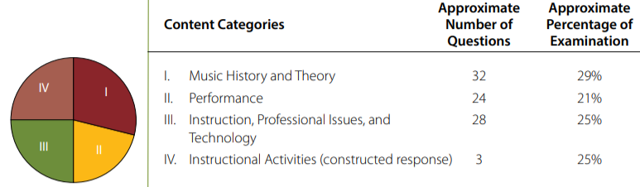

Figure 1. Content Categories for Praxis exam test code 5114 “Music: Content and Instruction”

Study Companion: https://www.ets.org/pdfs/praxis/5114.pdf

