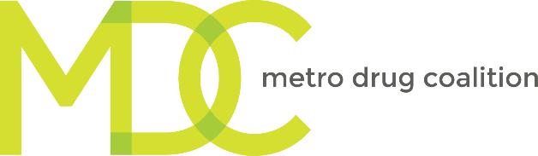

Preventing Neonatal Abstinence Syndrome
Through Assessment & Physician Guidance

February 22, 2019
12:00 PM – 3:30 PM
University of Tennessee Medical Center
Heart Hospital Conference Room
1924 Alcoa Hwy, Knoxville TN 37920

AGENDA & LEARNING OBJECTIVES
Schedule | Speaker & Topic | Learning Objective(s)  “As a result of participating in this activity, the attendee will…”
12:00 PM – 12:20 PM  12: 20 PM - 12:35 PM | Welcome  Karen Pershing, MPH, CPS II  Executive Director, Metro Drug Coalition  Craig Towers, MD, UTMC  Specialist in Maternal-Fetal Medicine/Obstetrics & Gynecology
12:35 PM – 1:15 PM | Overview of the Disease of Addiction  Stephen Loyd, MD  Medical Director, JourneyPure | - Identify signs and symptoms of acute opiate withdrawal  - Identify risky prescribing practices of controlled substances
1:15 PM – 2:00 PM | What is SBIRT?  Karen Pershing, MPH, CPS II  Executive Director, Metro Drug Coalition | - Understand the disease process of addiction  - Recognize the risk factors and causes of Neonatal Abstinence Syndrome  - Understand the process of SBIRT  - Discover ways to implement the screening tool  - Learn how to provide a brief intervention  - Learn about community resources

 | SBIRT: Screening  Karen Pershing, MPH, CPS II  Executive Director, Metro Drug Coalition | - Describe importance of universal screening  - Describe an important screening tool for pregnant women, (5 Ps)  - Describe the Alcohol, Smoking and Substance Involvement Screening Test (ASSIST)  - Describe how this may be part of your office’s clinic flow  - Provide billing codes
2:00 PM – 2:10 PM | Forms of Voluntary Reversible Long Acting Contraceptives (VRLAC) Available  Annabel Henley  Program Director, Women’s Health  Knox County Health Department | - Identify the three different types of Long Acting Reversible Contraceptives  - Understand the difference between unintended pregnancies in the general population and the addiction community  - Understand the approach taken by the KCHD to prevent the rise of Neonatal Abstinence Syndrome in East Tennessee
2:10 PM – 2:30 PM | SBIRT: Brief Intervention  Sharon K. Davis, DNP, WHNP-BC  Clinical Assistant Professor, Women’s Health, College of Nursing, University of Tennessee-Knoxville | - Identify the 5 steps of Motivational Interviewing (MI) as they relate to brief interventions  - Recognize substance use and abuse issues in patients  - Use evidence-based practices to approach patient treatment of substance abuse
2:30 PM – 3:00 PM | Using the Controlled Substance Monitoring Database  Michael O’Neil, PharmD  Professor and Vice Chair, Department of Pharmacy Practice, Drug Diversion/Substance Abuse Specialist, College of Pharmacy, South College | - Briefly discuss basic clinical applications and considerations of Prescription Drug Monitoring Programs (PDMP)  - Identify and discuss limitations of the PDMP  - Implement simple strategies that optimize utilization of PDMP

3:00 PM – 3:25 PM | SBIRT: Referrals — Treatment Options  Jason Goodman, CPRS  Regional Lifeline Director,  Metro Drug Coalition | - Become more informed concerning criteria to enter certain types of treatment.  - Become more informed concerning the available treatment resources in the community.
3:25 PM – 3:30 PM | Follow-up Survey, Wrap-up, and Evaluation

