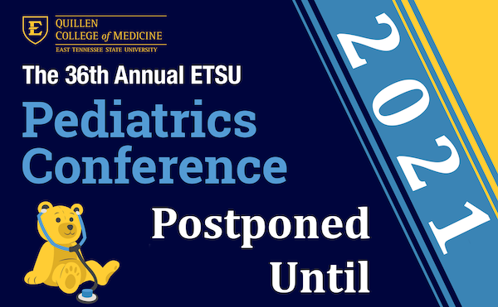

Good afternoon. The planning committee began meeting several months ago to determine topics and identify and secure speakers for the 36th Annual ETSU Pediatrics Conference. When we started the planning process we never imagined that we would find ourselves in the midst of a worldwide pandemic where social distancing, working from home, holding meetings via teleconferencing, and using telemedicine for many routine patient appointments would become the norm. However, that is indeed the scenario under which we are currently operating in order to flatten the curve and save lives.

The planning committee recently held a teleconference to discuss our options for moving forward with this conference. Due to the current guidelines set forth by the CDC, the governor of Tennessee, and East Tennessee State University, it became apparent that if we moved forward this conference would need to be a virtual conference only in order to make appropriate accommodations for the health and well-being of everyone. We then began to discuss how we could hold an 8-hour conference via live broadcast and provide the ability of our audience to easily interact with our speakers. It became apparent that while the live broadcast format works for our pediatric bi-weekly grand rounds, it would be a challenge to structure the conference with close to 100 participants in a manner that would be conducive to learning and sharing.

Therefore, after careful consideration, the planning committee has decided to postpone the 36th Annual ETSU Pediatrics Conference until 2021. We plan to incorporate the speakers we had solicited for our conference into our grand rounds sessions. Please click here to access more information on Pediatric Grand Rounds.
We hope that everyone stays safe and well this summer and we look forward to seeing you soon.

