The Medical Student Education Committee (MSEC) of the Quillen College of Medicine met on Tuesday, April 20, 2021, via Zoom meeting.

Attendance

Faculty Members | Ex Officio Non-Voting Member
Ivy Click, EdD, Chair | Ken Olive, MD, EAD
Caroline Abercrombie, MD
Martha Bird, MD | Subcommittee Chairs
Thomas Ecay, PhD | David Wood, MD
Jennifer Hall, PhD
Russell Hayman, PhD | Academic Affairs Staff
Jon Jones, MD | Kortni Lindsey, MAgr. Staff
Paul Monaco, PhD | Mariela McCandless, MPH, Staff
Jason Moore, MD | Aneida Skeens, BSIS, CAP-OM
Jessica Murphy, MD
Antonio Rusinol, PhD | Guests
 | Lorena Burton, CAP
Student Members | Leon Dumas, MD
Sarah Allen Ray, M3 | Lindsey Henson, MD, PhD
Andrew Hicks, M1 | Tom Kincer, MD, AD
 | Skylar Moore, HCMC, BSPH
Ex Officio Voting Members | Jerry Mullersman, MD, PhD, MPH
Joe Florence, MD | Tory Street, AD
Tom Kwasigroch, PhD | David Taylor, M4
Rachel Walden, MLIS

Meeting Minutes
- Approve: Minutes from March 16, 2021 Meeting.
Dr. Click opened the meeting at 3:35 p.m. and asked for comments/updates to the March 16, 2021 meeting minutes, which were distributed with the MSEC meeting reminder.
Dr. Monaco made a motion to accept the March 16, 2021 minutes as presented. Dr. Rusinol seconded the motion. MSEC approved the motion.
The MSEC minutes for March 16, 2021 were shared with MSEC Members via Microsoft Teams document storage.
Announcements:
- Faculty Development –
  - April 21 at 12:00 pm, Dr. Jim Holt and Dr. Jeffrey Summers will be presenting Patient Safety: Recognizing Medical Errors and Addressing with Quality Improvement. Zoom link was sent out with the invite. Anyone wishing to attend who did not receive the link should contact Dr. Click.
  - May 19 at 3:30 pm, Dr. Trena Paulus will be presenting a session on Educational Research.
- CTSC Town Hall meeting – Tuesday, April 27 at 5:00 pm. This will be a recap of items that MSEC has approved and provide an opportunity for a Q & A session. Dr. Henson will also be giving a brief presentation.
- Book club – There will be a summer book club, but the book choice has not been solidified yet.
- CMS work group update – There have been several software demonstrations and the group is obtaining pricing information and will then determine if any additional demonstrations are needed. The goal is to have a new CMS in place by January of next year, so it is up and running to use for scheduling before the next group of clerkships begin, and also to input the new curriculum information into the system before its implementation in the 2022-2023 academic year.

- Update/Action: Periodic Comprehensive Review Policy – Update to add CQI Plan - Dr. Click

The Periodic Comprehensive Review Policy was updated to add language regarding the Continuous Quality Improvement (CQI) process and CQI plans previously been approved by MSEC.
- Language was added to state that course/clerkship directors may be required to submit a CQI plan to MSEC based on the results of their course/clerkship review.
- The responsibilities of course/clerkship directors were also updated to reflect that the course/clerkship director is responsible for submitting a CQI plan if requested. Sentence wording was also clarified to reflect that the annual or comprehensive self-study was to be submitted within 30 days of distribution of course evaluations and self-study forms.
- The M1/M2 and M3/M4 subcommittee responsibilities were updated to reflect that the subcommittees would make determinations about whether a course/clerkship was meeting expectations using an approved course/clerkship rubric and the subcommittee would recommend if course/clerkship directors should complete a CQI plan dependent upon the findings of the course/clerkship review.
- Language was also added to identify specific triggers for recommendation of a CQI plan.
  - Any single element (e.g., Assessment, Feedback, and Grading or Educational Outcomes, etc.) on the course/clerkship review rubric with two or more items rated as below expectations
  - Three or more total items rated below expectations
  - Prior recommended changes not addressed with no reasonable explanation
  - Other circumstances as identified by the curriculum review subcommittee, MSEC, or EAD

Dr. Abercrombie made a motion to accept the Periodic Comprehensive Review Policy as presented. Dr. Hayman seconded the motion. MSEC discussed and approved the motion.
The presented Periodic Comprehensive Review Policy document is shared with MSEC Members via Microsoft Teams document storage.

- Discussion: Curriculum Transformation - Dr. Click and Dr. Rusinol

Dr. Click shared the timeline to show where we are in the curriculum transformation process and we are on schedule with our goals for April – structure of the typical week, assessment model, pedagogy, and Doctoring changes. Dr. Click pointed out that a lot of the specific Doctoring changes have not been made yet but there is a group working on this and there should be more information on this available in the near future. We are still aiming for submission of the major curricular change to LCME in December.

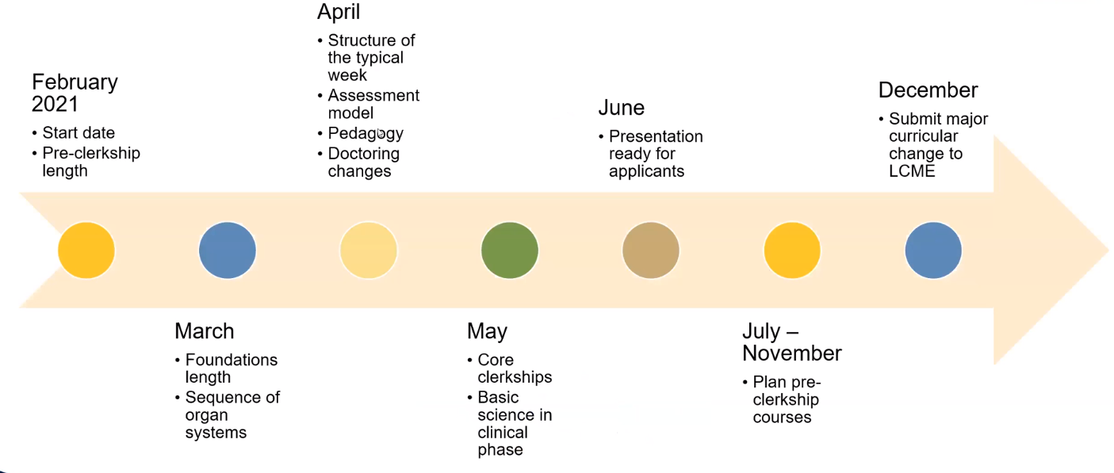
Dr. Click reviewed the major curriculum decisions that have already been made and what the next steps are. The next steps include:
- Structure of the typical week
  - Assessment and Pedagogy
- Pre-clerkship Course Directors and design teams selected
  - A document entailing the job description for the course directors will be sent out in the near future to faculty who are interested in a course director role.
- Possible clerkship changes
  - The clerkship directors met to discuss how to transition the clerkships to begin in March and what calendar changes would need to take effect for that.
- Planning Accelerated Track
  - Dr. Fox has been identified to lead this group once a group has been associated with that.
- Name the curriculum
  - TRAILS has been discussed as a potential name for the new curriculum. TRAILS stands for Team-based Rural Applied Integrated Learning System. One of the things discussed was having a name that was unique and connected to our region such as the Appalachian Trail. This could also be incorporated into various aspects such as learning communities, which could be named for mountains in the region or something similar. Dr. Click asked for feedback before making any announcements.

Additionally, Dr. Pierce has also agreed to lead the Learning Communities group and faculty who identified they were interested in working on that group should get some information on that in the near future.

Dr. Rusinol provided a presentation on behalf of the Instruction and Assessment Task Force (IATF) with their recommendations for assessment and pedagogy. He reviewed the Curriculum Transformation Steering Committee’s (CTSC) guiding principles with respect to the change in the curriculum and discussed the IATF charge.

For instruction, Dr. Rusinol used a metaphor of pillars to explain the concept the IATF recommends for instruction noting that the foundation for the pillars was the materials faculty provided outside of class along with the students using protected study time to prepare for class. The “pillars” of the concept are active learning, knowledge application, reflection and teamwork and these pillars will be the basis for a continuous assessment progressive program allowing students to obtain mastery of the pre-clerkship curriculum.

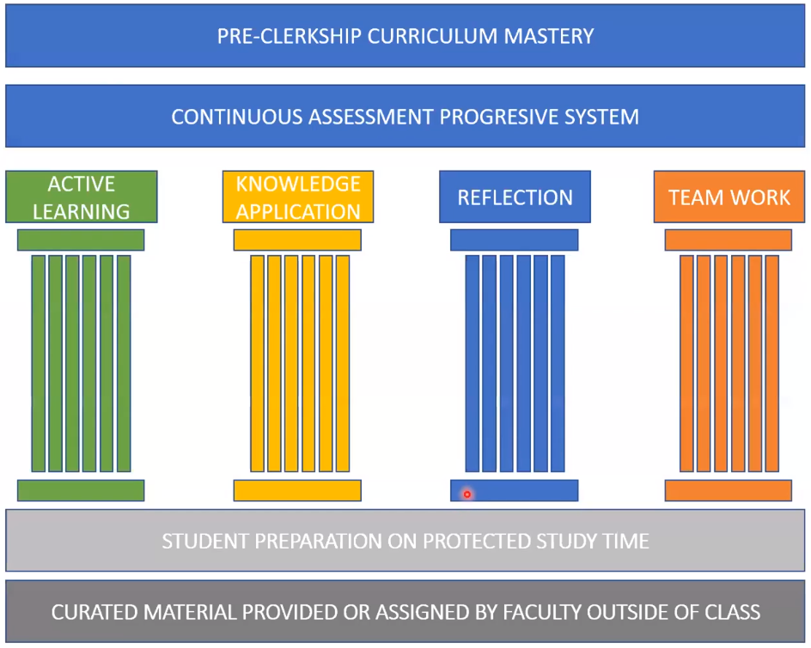

It was recommended that the students have 20 hours of scheduled contact time per week when possible, with a maximum of 24 hours and a target of two hours or less of self-directed study time per one hour of contact time.
- Most learning activities should be based on active learning principles using team-based learning (TBL) sessions three to four days per week for the basis of the delivery of the curriculum.
- Case-based learning (CBL)/Problem-based learning (PBL) and Systems, Professional, Ethical, and Community Topics Relevant to Medicine (SPECTRM) would occur on Fridays with one PBL/CBL case covered over two consecutive weeks and SPECTRM/Lifelong Learning occurring every third Friday.
- Interactive large-group sessions would also be utilized to provide diversity in pedagogy, and also provide a more hybrid methodology for faculty who are not comfortable or not trained on team-based learning.
- Learning communities would also take place once every four to six weeks.

A typical weekly schedule was discussed, and a sample schedule was provided:

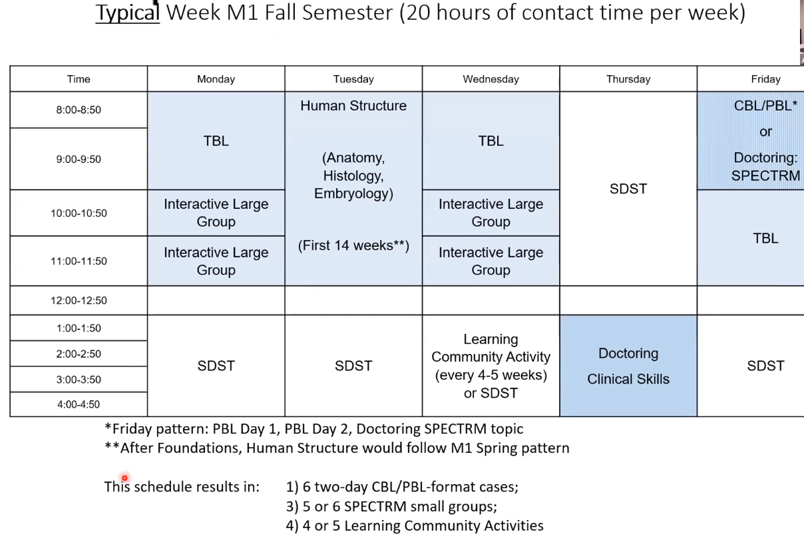

The goal is for students to have a consistent/predictable schedule as much as possible during the first two years although there may be some variation from week to week depending upon required activities. For example, Doctoring may have groups attending on different days due to scheduling restrictions for sim lab/SPs, etc. and IGR/IPE and other infrequent activities would also have to be considered. Dr. Rusinol pointed out that students would have a chunk of time each day as protected study time (SDST on the sample schedule) instead of an hour here and there to prepare for the activities of the week. It was noted that 20 hours of contact time would mean 40 hours of study time but the sample only showed 20 hours of study time. Dr. Rusinol explained that there was obviously self-directed study time that occurred after 5:00 p.m., but there are generally not pre-clerkship activities scheduled after 5:00 p.m. so there was nothing more to include on the sample schedule. Dr. Kincer pointed out that modifications might be necessary to the schedule for Doctoring II as the schedule only allowed for half-days for clinical doctoring skills and the travel time to get to the rural clinical sites for rural track students would impact their ability to get meaningful exposure as they would spend a good deal of their time traveling to and from the site. He also pointed out that a lot of doctors in the rural areas begin winding down appointments in the afternoons so students may not have much exposure to patients in that afternoon timeframe. It was suggested that perhaps rural track students could switch the activities on those days and do their precepting during the morning hours and have the afternoons for their SDST. Dr. Click thought this might be beneficial for all preceptorships to be done during morning hours and then use afternoons for SDST. Dr. Kincer also stated he would like to see the group get out of the pod mentality where rural track students try to do everything in Rogersville or Mountain City and have the rural track students do some of their skills, such as standardized patients and didactics with the larger group then utilize the rural sites for their experiential learning. Dr. Henson pointed out that it was not set in stone when the protected time was, but once protected time was established it was truly protected time and could not be taken away from the students. It was noted that the SDST on the sample schedule were placed based on activities the students needed preparation time for. For example, if the student had a TBL session coming up, SDST was placed at some point before that session to give the student time to prepare for that. It was also noted that some of the basic science teaching could occur in the afternoon and some of the clinical teaching occur in the morning, supporting the idea that it is one curriculum, not basic science vs. clinical. Discussion was had regarding the term “self-directed” noting that self-directed does not mean the student has to study alone, students could choose to study in groups. Self-directed means that someone else is not scheduling time for the student, the student can prepare however they feel is best suited for them. It was asked if anything was being done in terms of the curriculum to teach students how to manage their time so that the SDST became valuable and not just unstructured time that they did not know how to use. The Student Affairs Office, academic counselors, and learning communities will be beneficial in helping students figure out the best strategy for them. It was noted that the consistency of pattern in the schedule through the whole pre-clerkship curriculum would foster time management behaviors as well.

For assessment, Dr. Rusinol stated that the charge was essentially to recommend a strategy that could be used in a pre-clerkship curriculum and recommend the ratio between formative and summative assessments and what methods of assessment to use. The IATF proposes a formative and summative system with a focus on the formative because it is a better fit for the essential tasks of competency-based medical education. This proposed model is based on continuous and progressive, low-stakes formative assessments leading up to a final assessment with higher stakes. A Continuous and Progressive System of Assessment (CAPS) would include the following:
- In-class formative assessments
  - TBL Grade (IRAT, TRAT, application, peer evaluation…)
  - In-class grade from audience response devices
  - Other assessments which could include narrative assessments (via rubrics), essays, papers, laboratory practical exams, mini clinical exercises, presentations, etc.
- Out-of-class assessments
  - End-of-week assessments
  - Midterm or interim exams (if used)
  - These assessments should include a portion of cumulative material and have progressively increasing stakes
- Final customized NBME exam

Having continuous assessments helps faculty identify students who are having trouble earlier so that they can provide support to those students early on. A comment was made that this would shift the focus from memorizing material into studying to learn so the students would know the information in context instead of just an answer on a test. It was also pointed out that there could also be assessments where teams produce a product, such as a research piece or grant, and the high stakes assessment is the final project.

Next, Dr. Rusinol discussed resources needed to implement the IATF’s recommendations:

Instruction resources for students
- Increased academic support
- Student development sessions on how to effectively seek, receive and use formative feedback
- Audience Response System/Device/License
- Investigate feasibility for partnerships with content creators like Osmosis

Instruction resources for faculty
- Content creation software:
  - Panopto or Camtasia
  - Active Presenter
- Training on audience response management
- Training on TBL best practices
- Templates for TBL or other interactive sessions (Clicker slides, in-class learning objective slides, feedback, and take-home slides, etc.)
- Pedagogical faculty development sessions on how to engage as coaches and how to use appropriate motivational techniques to encourage self-improvement in students.
- Faculty development and support on technical aspects of how to:
  - Write and review learning objectives for the study material and for the active learning sessions
  - Create, identify and adopt instructional methods guidelines
  - Curate and create self-directed learning materials such as:
    - Handouts, PDFs with chapter excerpts, assigned readings, etc.
    - Online videos with self-assessment
    - Narrated slide presentations
    - Interactive eLearning modules
    - Create IRAT/GRAT questions by using keywords and learning objectives and curate them into a 10-question readiness quiz
    - Assess alignment between Learning objectives and IRAT/GRAT quiz questions
    - Curate formative quizzes from question banks subscribed to by QCOM (Amboss, Vitalboards, etc.)
    - Recommend best practices for facilitating an active learning session
    - Observe and offer feedback on active learning sessions

Having dedicated time for faculty to teach, especially clinical faculty, for development was discussed. Having a clear incentive as either part of their FAP/FAR/FAE or tenure in promotions process would be very beneficial.

Assessment Resources:
- Testing center or study the feasibility to use the ETSU testing center
- NBME customized exams
- Online proctoring systems
  - D2L
  - Others

The ETSU testing center is not staffed on Saturday or Sunday and the possibility of hiring a part time person to work in the ETSU testing center during that time for medical students to come in for their weekly quizzes was discussed.

Dr. Rusinol noted some of the implications of the IATF’s recommendations would be:
- Guidelines set by MSEC to ensure that the pedagogy and assessment plans are implemented as intended.
- Student attendance mandatory any time in-class formative feedback counts towards grade.

This would potentially necessitate the following policy changes:
- NBME Policy for pre-clerkship courses
- M1-M2 syllabus identification of lecture / non-lecture attendance and assessments
- Student Promotion Committee policy

It was noted that changes to student attendance would be a cultural change for the students and that was a very important reason to have those blocks of protected study time because faculty would be expecting students to come to class and be prepared and engage in active learning and in return for that, students were getting large chunks of time when they were not required to be in class to be able to prepare for those things. Engaging the upperclassmen and getting buy in from them to support the new curriculum would be really important, especially the incoming M1 class because they would be the last group in the legacy curriculum and getting them to support the curricular change would help set the attitude for the culture shift.
Dr. Click noted that the incoming M1s could see some of the benefits of the changes that go beyond just the structure of the curriculum, such as participating in learning communities, having additional academic support, or potential changes in clinicals, they just would not see the overall shift in the integrated courses. She also noted that faculty could incorporate new and active learning methods into their courses now if they chose to do so at this point.

Dr. Click pointed out that this would require policy rewrites, such as the policy regarding NBME shelf exams and maximum number of contact hours per week and these were things that would have to be considered. She suggested coming back next meeting with specific items that would need MSEC approval. Dr. Kincer stated that we would need to have a clearer picture of what rural track was going to do. He also stated that rural track was poised for significant administration changes and it was time to rethink how to make rural track a more collaborative effort. Dr. Click suggested putting Dr. Kincer on an upcoming meeting agenda to discuss some of his thoughts and allow him to hear others’ thoughts to help him solidify his vision for the rural track program.

Specific items requiring MSEC approval will be discussed at the next meeting.
The presented Recommendations from the Instruction and Assessment group document is shared with MSEC Members via Microsoft Teams document storage.
- Discussion/Action: Option of four week or eight week elective for Orthopedics – Kortni Lindsay
Kortni Lindsay presented a proposed change to the duration options for the current elective known as “Orthopedic Surgery Elective – ETSU”. Currently, this elective is four weeks in duration. It is proposed to modify the duration of this elective to add the option of an eight week rotation in addition to the current four week rotation. There has been conversation regarding the need for students interested in orthopedics to have at least eight weeks of orthopedics experience and right now students do not have a way to get that much experience here. It was discussed and agreed that offering the additional time would be beneficial to students.

Dr. Abercrombie made a motion to accept the proposal to change the duration of the Orthopedic Surgery Elective – ETSU from the current four week option to be a four week or eight week elective for Orthopedic Surgery as presented. Dr. Jones seconded the motion. MSEC discussed and approved the motion.
The presented Orthopedic Surgery Elective document is shared with MSEC Members via Microsoft Teams document storage.
- Discussion/Approve: Patient procedure list – Kortni Lindsay

Kortni Lindsay presented the Clerkship Patient Procedure List for approval for the 2021-22 academic year. She noted that when COVID hit last year, a lot of clerkship specific required procedures were moved to be global requirements so that students could complete them on any clerkship throughout the year and they were signed off depending on what clerkship they completed the requirement in. This caused a lot of confusion for the students and also caused reporting issues in New Innovations. The recommendation today is to move these global requirements back to clerkship specific required procedures. Upon asking if any changes were necessary, it was noted that the Dysuria/UTI/Urosepsis requirement in Family Medicine needed to be changed to Dysuria/Complicated UTI instead because students were more likely to see a patient with a complicated UTI than a patient with urosepsis. Also, the hospital coding was different for urosepsis. The question was asked what you would put down if the location is neither inpatient or outpatient, such as a simulated experience or community experience and
due to the limitations in the recording features in New Innovations it was determined that if the location was not in a hospital, it should be considered an outpatient location. There were also questions regarding the wording of the level of student responsibility being assist or perform and it was noted that again, due to the limitations of the recording features in New Innovations, perform did not always mean that the student actually performed a procedure, but could also mean that they performed the requirement. After further discussion it was noted that these procedures and diagnoses would need to be looked at in the future to make sure they were in line with the new curriculum.

Dr. Jones made a motion to accept the Patient Procedure List as presented. Dr. Monaco seconded the motion. MSEC discussed and approved the motion.
The presented Patient Procedure List document is shared with MSEC Members via Microsoft Teams document storage.
- Report: M3-M4 Review Subcommittee 2020-2021 - Dr. Wood
- Transitions Component of Doc III

Dr. Wood presented a course review for the Transitions component of Doctoring III. Dr. Abercrombie is the course director. The reviewers were Dr. Jessica Murphy and Lindsey Merkle Moore, M3.
Goals, Outcomes, and Objectives: Met expectations. Clerkship objectives are linked to the Institutional Educational Objectives (IEOs) and the Entrustable Professional Activities (EPAs). Clerkship objectives assessment may have been limited due to the virtual setting but they met expectations. Individual sessions are not fully mapped but mapping is in the process and ongoing.
Content, Delivery, and Environment: Educational methods are appropriate. The virtual nature of the course made resources difficult. The faculty and residents exceeded expectations with their time and ability to teach. The learning environment met expectations, however, the students were largely unhappy with the virtual setting due to COVID, but the course went well despite limitations.
Assessment, Feedback, and Grading: Met expectations. There was no mid-clerkship formative assessment as the course is abbreviated into two weeks, including the asynchronous portion.
Educational Outcomes: Exceeded expectations. All students passed the course. There is no NBME exam associated with this course.
Student Feedback: Met expectations. Teaching quality of resident and attending teaching is not rated for this course. The overall evaluation of the Transition to Clinical Clerkship was rated as 3.69/5. Of note, the rating scale has since been changed to a four-point scale instead of a 5-point scale.
Previous Reviews: There were no recommendations made for prior reviews.
Strengths: Strengths listed by students were organization and adaptability, in-person and virtual skill sessions, online prep work provided unlimited review and independent pacing, and small group discussions.
Strengths listed by the clerkship director were talented and expert faculty with engaging approach to their sessions, active learning is a priority, prep materials for sessions provide the opportunity to perform and engage.
Weaknesses: Weaknesses listed by students were lack of in-person interaction made some things awkward and less engaging, synchronous vs. asynchronous scheduling was confusing, conflict with Ballad Health employees (addressed by Academic Affairs and Ballad Health).
Weaknesses listed by the clerkship director were that due to restrictions imposed by COVID, we had to eliminate in-person sessions in airway, pelvic exam and catheter placement. We felt that students would be likely to be exposed to these skills on their 3rd year rotations. All skills are planned to be back this year if that is relevant. With more time to schedule instructors, the increased availability of PPE, and improved awareness of how to handle skills sessions with distance we feel confident in handling all this year. There were some concerns expressed about D2L, but this is the platform used by the university for grading and paperwork. Dr. Abercrombie plans to continue structuring the modules as asynchronous (complete on your own) and synchronous (complete live, virtual or in-person, during the week of). The main reason being that the asynchronous content opens one month prior and in-person content for the week of is often not ready until the week prior.
Recommendations to the course director: Dr. Abercrombie should be recognized for gracefully handling the massive transition from in person to virtual of a complex course with lots of moving parts and pieces. Continue mapping session level objectives (Physical Exam for the Professional, How to NOT Have a Bad Day in Pediatrics, Simulated Knee Injection). If this course is continued virtually this year, based on student commentary it appears D2L added to the general confusion of when certain assignments were due vs when “live” events were scheduled. Dr. Abercrombie does still plan to use D2L for its gradebook and as a way to list the requirements of the course for the students, but will have time to make this clear on the new D2L site. Dr. Abercrombie is considering using an external site (Google or Microsoft teams), which may improve communication on course requirements and due-dates to students.
Recommendations for MSEC: None.
Dr. Click pointed out that the Transitions course had been absorbed by Doctoring III and it was not a true clerkship so it was not entirely suited for the new rubric MSEC approved. She also noted that consideration would have to be given to review for the other components of Doctoring III – Content Sessions Seminar Series and Career Exploration or alternatively if the course would be reviewed overall in the future. Dr. Click also noted that if Transitions expanded to three weeks in the new curriculum, there may need to be consideration given to making it its own course instead of a Doctoring III component.
Additional discussion: Dr. Abercrombie brought up the subject of mapping and pointed out that her mapping had been different for the past three years due to changes in the course and would probably continue to be different for the next three years due to the transition to the new curriculum and questioned the need for faculty to map the current 2020-2021 academic year as opposed to rolling over the previous year’s mapping since this will be the last year in the legacy curriculum and the event sessions will probably be changing with the new curriculum. Dr. Click agreed and wondered how much time we wanted to put into mapping for the 2020-2021 academic year since it will be the last year of the current curriculum. This discussion needs more thought and will be brought back to MSEC in a future meeting.

Dr. Hayman made a motion to accept the Transitions Component of Doctoring III Annual Course Review as presented. MSEC discussed and approved the motion.

Mapping will be a point of discussion for a future meeting. No action was taken.
The presented Transitions Component of Doctoring III Annual Course Review is shared with MSEC Members via Microsoft Teams document storage.

- Update: NBME Clerkship failure rate - Kortni Lindsay

Kortni Lindsay provided an update regarding the NBME clerkship failure rate stating that since the last report, there had only been one additional failure of an NBME. Overall there have been six students total who have failed a repeat NBME. She noted we have seen less failures as the year has progressed as was hoped. It was asked if any of the six students failing repeat NBMEs had failed more than one clerkship. Kortni stated she would have to look at that but she thought there was one student who had failed multiple NBMEs and has to repeat multiple clerkships and the student had taken a leave of absence. Dr. Click stated the reason for continued monitoring was to see if the failures declined as the year progressed because it was felt that the increase of failures was likely due to students not having taken Step I so they were spending more time studying for Step I than the NBMEs. Kortni reported there had been no failures during the last two NBME exams besides the retake.

No action required for this item.
The presented NBME Clerkship Failure Data document is shared with MSEC Members via Microsoft Teams document storage.

- Discussion: Returning to a Live Environment - Dr. Click

Dr. Click led a discussion regarding the College of Medicine returning to a live environment. Masks will still be required for the foreseeable future for any activities occurring in person. The following are the recommendations for the College of Medicine for the 2021 Fall course delivery. It was noted that the cases provided below were intended as examples only and were not an exhaustive list. Dr. Click noted that Dr. Fox was available to speak with anyone having questions about specific spacing.

- In-person recommended:
- When possible to safely distance
- Classroom capacity will be decided for each space prior to the start of the year.
  - When “hands-on” experience is beneficial
- Simulation
- Standardized Patient exams*
- Labs
- Clinical rotations
  - When face-to-face interaction is needed/beneficial
- Small group meetings
- High interactivity/engagement
- Relationship building
- Sensitive topics

- Online/Virtual recommended:
  - When not possible to safely distance
- Adequate classroom space not available
- Consider hybrid design with some in-person and some online if needed
- When online experience offers advantage(s) to in-person
- Managing small group “breakouts”
- Students at “offsite” location

*Assumes sufficient SPs willing to work in-person

Definitions of Modes of Instruction:
In-person
- Has a meeting pattern and assigned classroom
- Synchronous in-person delivery of course material
- May have a small amount of asynchronous material
Hybrid
- Has a meeting pattern and assigned classroom
- Includes both in-person and online components
- May involve synchronous and asynchronous delivery of course material
- Supports a range of course designs:
- In-person class for portion of students with remaining portion on Zoom on rotating basis (Group A meets Monday; Group B meets Wednesday)
- Recorded lectures with in-person labs or simulations
- Flipped classroom with recorded lectures with synchronous group discussion or other active learning modality
Online Synchronous
- Has a meeting pattern, but no assigned classroom
- Remote synchronous meetings through Zoom
- Can involve combination of synchronous and asynchronous components
Online Asynchronous
- No meeting pattern or assigned classroom
- All material is delivered asynchronously
- A student can participate fully regardless of time or location

It was asked if exams would be given by ExamSoft as concerns were expressed of online exams not being proctored and question banks no longer being secure going forward. Dr. Click stated that these recommendations did not specifically address exams and that is something that would need further discussion. Comments were made that retired facilitators may still be uncomfortable in-person in small spaces and the question was asked if those facilitators would still have the opportunity to do their groups by zoom. Dr. Click stated that it would be preferred that small groups for a course be either all in-person or all in zoom because differences among groups could cause issues with students wanting to switch groups. Dr. Click suggested reaching out to facilitators to determine if this was a legitimate issue or if this were just speculation. She pointed out that vaccinations were available to anyone at this point. She also noted that first and second year students could not be required to take the vaccination.

No action required for this item. The issue of having exams in-person vs. online and the question of facilitators not wanting to participate in in-person settings will require further discussion with course directors.
The presented Fall 2021 Course Delivery Recommendations document is shared with MSEC Members via Microsoft Teams document storage.
The MSEC meeting adjourned at 6:00 p.m.

MSEC Meeting Documents
MSEC Members have access to the meeting documents identified above through the shared Microsoft Teams document storage option made available with their ETSU Email account and login.

If you are unable to access Microsoft Teams MSEC Team please contact: Aneida Skeens at: skeensal@etsu.edu. Telephone contact is: 423-439-6233.

MSEC Meeting Dates 2020-2021:
May 18 – 3:30-6:00 pm - Zoom meeting
June 15 – Retreat 11:30 am-3:00 pm – Zoom meeting
June 15 - Annual Meeting - 3:30-5:00 pm – Zoom meeting

MSEC Meeting Dates 2021-2022: (Location TBD)
July 20, 2021 – 3:30 – 6:00 pm
August 17 – 3:30-6:00 pm
September 21 – 3:30-6:00 pm
October 19 – Retreat – 11:30 am-5:00 pm
November 2 – 3:30 – 5:00 pm*
November 16 – 3:30-6:00 pm
December 14 – 3:30-6:00 pm*
January 18, 2022 Retreat – 11:30 am-5:00 pm
February 15 – 3:30-6:00 pm
March 15 – 3:30-6:00 pm
April 19 – 3:30-6:00 pm
May 17 – 3:30-6:00 pm
June 21 - Retreat -11:30 am-3:00 pm
June 21 - Annual Meeting - 3:30-5:00 pm

