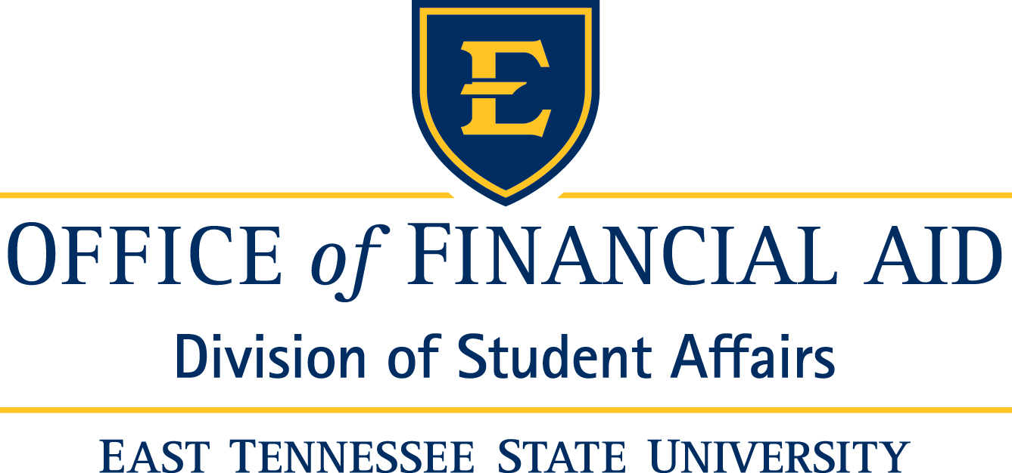

Financial Aid Information
National Student Exchange (NSE), International Student Exchange Program (ISEP), and Study Abroad

Can I receive financial aid for these programs?
Yes, financial aid is available to those who qualify. You must be enrolled in classes that have been approved to count as credit towards your degree. You also must be enrolled in the number of credits required for your awarded aid.
Things you should do to make the process easier:

- Contact Amy Collins in Financial Aid at least two months before you leave to resolve any outstanding issues that could impact disbursement of your financial aid.

- Add a First Mate on GoldLink if you want someone else (i.e., parents/spouse) to have access to your financial aid information in your absence. Instructions can be found online at www.etsu.edu/firstmate.

- If you plan to receive a balance of financial aid refund, we recommend that you complete an authorization for direct deposit. This can be completed online at https://epay.goldlink.etsu.edu/C20071_tsa/web/login.jsp.

- Check your email regularly. Since you may have easier access to email while away, most correspondence from our office will be sent to your Goldmail account.

- Contact Amy Collins in Financial Aid again, at least two weeks before you leave to make sure that all paperwork is complete and that your balance of financial aid will be available prior to your departure.

- Request a transcript from your host institution prior to returning to ETSU. Why? Your future financial aid will be placed on hold until ETSU receives your transcript. This is the only way that we can ensure that you have met all Satisfactory Academic Progress standards.

Frequently Asked Questions:

- What happens if you don’t receive my transcript before my fees are due for the next semester? You can contact Amy Collins in Financial Aid to obtain an ETSU Promise to Pay (if you have financial aid pending). This will postpone your fee payment until ETSU receives the transcript from your host institution.

- I have an Academic Performance Scholarship. How does that work?
You have two options:
  - Fulfill the 75-hour work requirement before your departure by submitting the APS Pre-Work APS Service Hours Request form. (Please contact Amy Collins in Financial Aid to get this form). You must also maintain all other standards required for the APS Scholarship.
  - Waive the APS award and its work requirement for the semester you will study abroad. You will need to turn in a written statement to financial aid requesting to have the APS put on hold until you return. You will then receive the scholarship again upon your return.

- Can I have my Lottery Scholarship while on one of these programs?
Yes, as long as you maintain continuous enrollment and have met all other qualifications necessary to receive the scholarship.

**PLEASE NOTE: If you are receiving the Lottery Scholarship on a provisional basis, you will not receive the Lottery upon your return until you reach the next benchmark (if eligible at that time, benchmarks occur every 24 attempted credit hours).

- Is there anything special that I need to do about a Summer Study Abroad program? Since many students exhaust their student financial aid eligibility during the fall and spring semesters, it is important to reserve some of those funds to help cover the cost of a summer study abroad program. You should visit the Office of Financial Aid early to discuss your particular eligibility.

**PLEASE NOTE: A student must be enrolled in at least 6 credit hours to be eligible for the Lottery Scholarship or Federal Direct student and parent loans. The 6 credit hours can be taken during any term within the summer semester.

- Are there scholarships available for NSE, ISEP, and Study Abroad? Yes, you can visit the International Studies webpage for information about scholarships at http://www.etsu.edu/honors/international/abroad/scholarships/default.aspx.
You can also visit the ETSU Scholarship Office webpage at www.etsu.edu/scholarships.

East Tennessee State University
Office of Financial Aid
Room 105, Burgin Dossett Hall
P.O. Box 70722
Johnson City, TN 37614
(423) 439-4300
finaid@etsu.edu

Amy Collins: collinsa@etsu.edu

