DW Exception How to Guide

How to enter Also Allow exceptions using DW
- Click Exceptions Tab
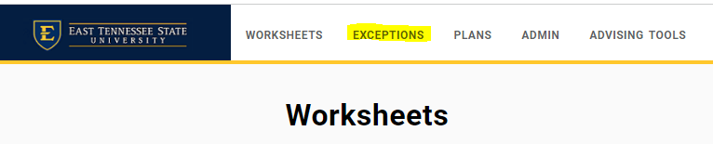
- Find requirement that you want to edit
- Click on the +
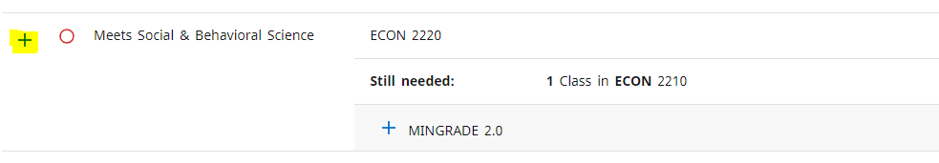
- In the new window, choose Also Allow under Exception Type
- Fill in the Subject rubric and Number of the substituted class
  - Example: ECON 2020
- Add Description
  - “Allow ECON 2020 for ECON 2210”
  - In this instance ECON 2020 is the substituted class and ECON 2210 is the required class
- The detail field does not show on the audit so you can leave blank.
- Click Add Exception
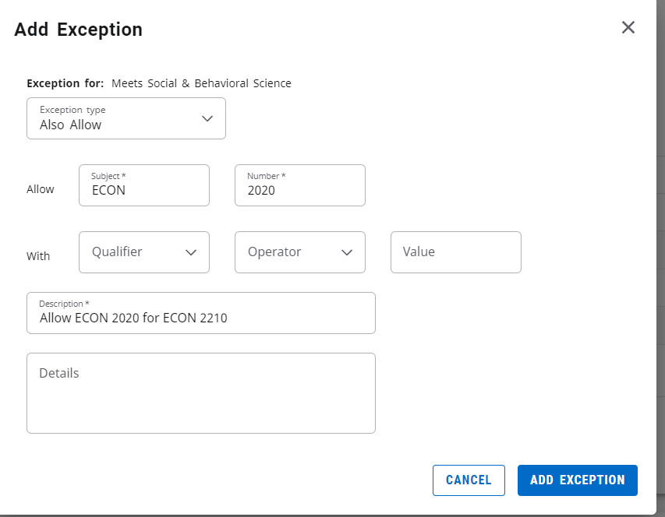
- The exception should now save
- Click Worksheets
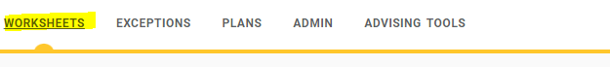
- Find requirement and ensure exception has been added
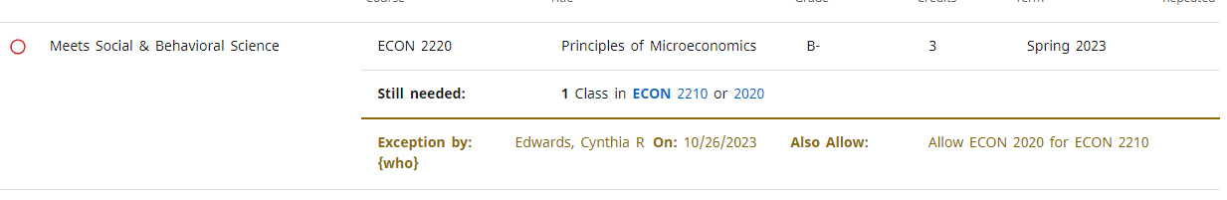
- If the substituted class has not been completed yet, or not In-Progress it will show as an OR
  - Technically, the student should still be able to choose the required course, so that course has to stay as a choice
- Once one of the courses has been registered for, it will show as In-Progress like normal
- Add note that defines exception

How to add a note in DW
- Click on the three dots in the right corner of the worksheet then Notes
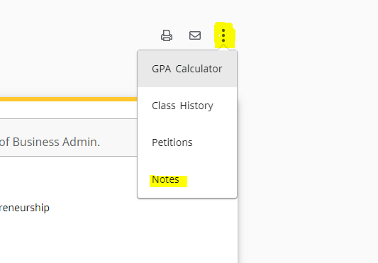
- Click “ADD A NEW NOTE”
- Add description:
  - Example: Allow ECON 2020 for ECON 2210 per advisor’s name (or whomever is approving exception)
- SAVE NOTE
- The note will appear at the bottom of the audit. The notes cannot be deleted and will save with the final audit for graduation conferral processes.

How to add an Also Allow Exception for a transfer elective
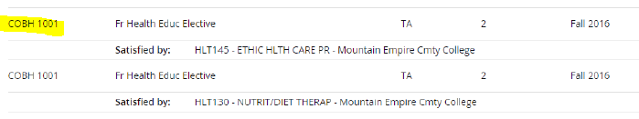
- Use the “with qualifier” section of the exception window to specify which class to add
  - Qualifier: DW Transfer Course
  - Operator: equal to
  - Value: the transfer course as listed on worksheet
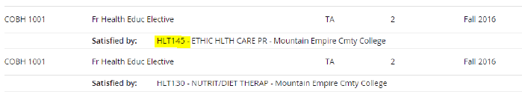
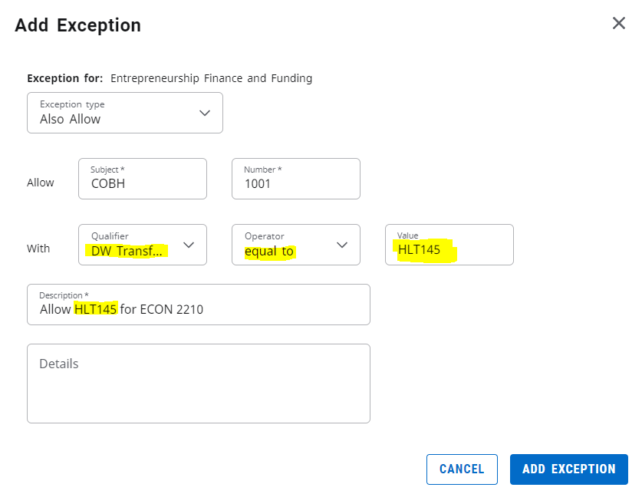
- Add exception
- The exception should now save
- Click Worksheets
- Find exception to ensure it was added correctly
- Add note
  - Example: Allow HLT145 for ECON 2210 per advisor’s name (or whomever is approving exception)

