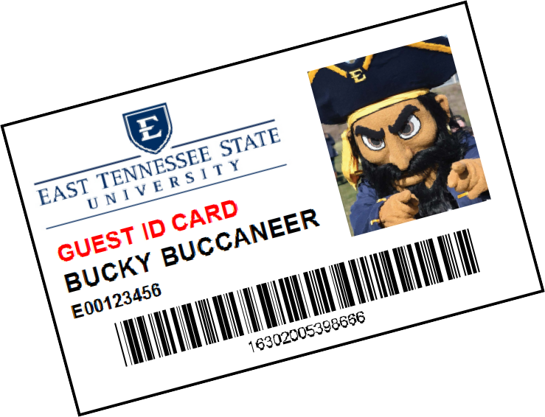
Guest ID Card Request Form
Please fill out the fields below to request an ID card for those in your department or program who need an ID card who are not affiliated with ETSU. Each special ID costs $10 and is to be paid by either the department or the individual receiving the badge prior to printing. After the initial card, the price for any replacements are equal to that of an ID card replacement, which is $27.38.
Please note: Special IDs only need to be requested to those who are on campus and require access to buildings or rooms to carry out their responsibilities.

Name:
Is there an E# assigned? (If not, a generic number will be assigned by ID Services): E#:

Card Information
All cards require a title or description to identify each individual's association. Please indicate below how the card should be displayed:
Special ID Classification:
Department: Card deactivation date (required):

Payment:
Will the department be charged for the badge(s)? (please circle): Yes / No
If "yes" please provide account code to charge:
By selecting "yes" above and providing an account code, you agree to the charges and allow Campus ID Services to withdraw the total amount charged from the account provided during the next billing cycle.

Approved by: Date:
(print)
Title & Department: Phone: Signature:
Office Use Only: Initial:

Date:

