Undergraduate Curriculum Committee
Meeting Notes
September 9, 2020

Members Present Rhonda Brodrick, Julie Bowers, T. Jason Davis, Tabitha Fair, William Flora, Julie Fox-Horton, Casey Gardner, Dana Harrison, Drew Howell, Myra Jones, Sookhyun Kim, Scott Koterbay, Tony Pittarese, Evelyn Roach, Laurie Schroder, Kimberly Sell, Melissa Shafer, Jonathon Taylor, Jennifer Young

Members absent None

Guests Present None

The UCC meeting was called to order at 2 p.m. by Tony Pittarese. Due to COVD-19 social distancing restrictions, the meeting was conducted by Zoom. Roll was taken by Rhonda Brodrick; new members were welcomed to the committee.

Old Business:

Propose New Course: SOWK 4347/5347 Indigenous Approaches to Environmental Justice in Social Work – This proposal was tabled at the 2/21/20 meeting for concerns related to course overlap. Tony Pittarese met with representatives from the departments of Social Work and Anthropology to discuss the overlap concerns. The proposal was custom routed to the originator for revision based on feedback from this meeting. The revisions were returned to Tony, and he approved the proposal.

Propose New Course: SOWK 4357/5357 Self-Care for Helping Professionals - This proposal was tabled at the 2/21/20 meeting for concerns related to course overlap. Tony contacted the originator, but there has been no movement on this proposal. Casey Gardner was asked to custom route the proposal back to the originator.

New Business

Tony Pittarese reported the UCC has 5 proposals pending review. GCC has approximately 40 courses pending.

Tony provided an overview of the curriculum process. Once the originator launches the proposal, the proposal is vetted by the shadow group (Casey Gardner, William Flora, Evelyn Roach). From there, the proposal moves to the Department Chair, College, and Dean levels before coming to the UCC for review. The purpose of the UCC is to review for the university level. The committee is not focused on editorial changes (typos, spelling, punctuation); the focus is on the structure/substance of the course (leveling, objectives, outcomes).

The UCC meets twice a month on the 2nd and 4th Wednesdays. The closure dates for submitting proposals are on Fridays, and these dates are posted on the UCC website. Tony publishes the agenda for each meeting by the Monday after the close date which is about 10 days prior to the scheduled meeting.

Work prior to the meeting: The goal is to clean the proposal up as much as possible prior to the UCC meeting. Tony will assign each proposal 2 reviewers (pairing a newer committee member with a more experienced reviewer). The reviewers have 1 week to review and work with the originator to make revisions. The reviewers provide written feedback to the originator by e-mail prior to the meeting. The second reviewer, UCC chair, and secretary are copied on these e-mails. The reviewers collaborate with the originator to clarify/revise information in the proposal.

Work during the meeting: The originator will provide a brief overview of the proposal. The reviewers will present a summary of any work completed in conjunction with the originator prior to the meeting. There may be additional discussion with the full committee to clarify any remaining questions, then the proposal is voted on by the committee.

Tony Pittarese thanked Tabitha Fair and Dana Harrison for creating the Undergraduate Curriculum Committee Helpful Tips handout (see attached). Tabitha and Dana led the members through practice reviews of two courses which will be formally reviewed at a later meeting. Questions from new and returning members were fielded to clarify processes and expectations. Members were reminded several times to make sure each field’s content meets the specifications of the help instructions for the field.

Casey Gardner, Evelyn Roach, and William Flora oriented members to the new Curriculum Innovation Center website. The site contains additional information related to frequently posed questions in addition to reviewed and edited forms. The shadow team is hosting drop-in Zoom meetings 3 days each week (Tuesday, Thursday, and Friday) for proposal originators or anyone with questions related to curriculum process. The following tabs were viewed:

- Syllabus Resources
  - Syllabus Attachment – information included in the syllabus attachment and a link to the attachment
  - Syllabus Template – generic templates for various colleges/departments
- Curriculum Process
  - Terminology – defines terms that have been confused in the past (i.e., course repeatable for credit vs. course repeated for credit)
  - Curriculum Actions – a list of actions taken in the past academic year and pending actions

The meeting was adjourned by Tony Pittarese at 3:30 pm.

Respectfully submitted,

Rhonda Brodrick, UCC Secretary

Approved by UCC 9/23/20

Undergraduate Curriculum Committee Helpful Tips

Navigating Curriculog

Login to Curriculog and locate assigned proposals. Click to Edit the proposal which will take you to a new screen.

This screen includes all notes from the originator or during other steps of the proposal process to this point. Review existing notes. These notes can contain important information. There are also times when the proposal was submitted prior to the current year and notes are helpful to get caught up with the history. Select the Show Help Text option on the left panel.
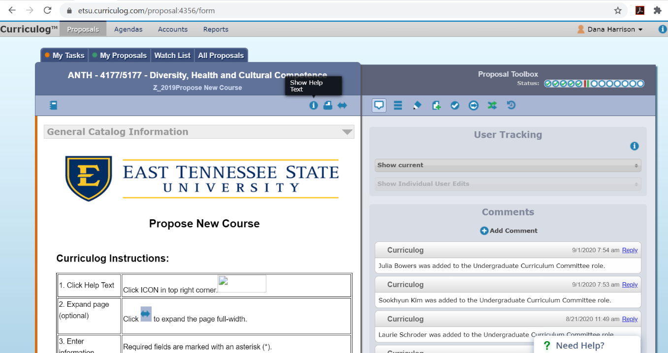

To view any attachments to the proposal, click Files in the right panel of the screen.
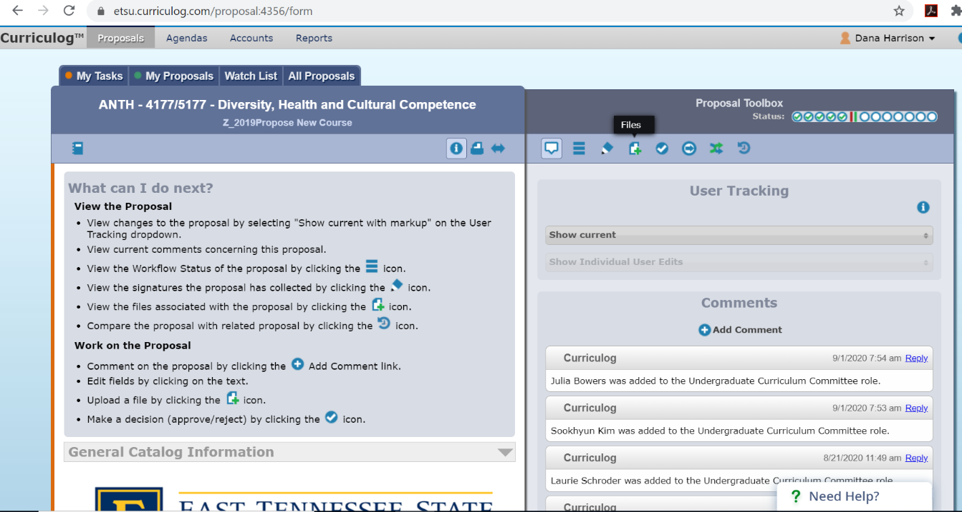

It is helpful to review the proposal content with the Help instructions since you can easily compare the content with what is required. For example, Help instructions for Major Assignments, Exams and Grade-Weight Values require the following: Bulleted Format, Name of the Assignment/Exam (Graded/Weight), Description of the assignment/exam. Examining the proposal below, it is suggested that a description be added to the first assignment and read something such as: Mid-term exam (25%) – Multiple choice exam covering material from weeks 1-7.
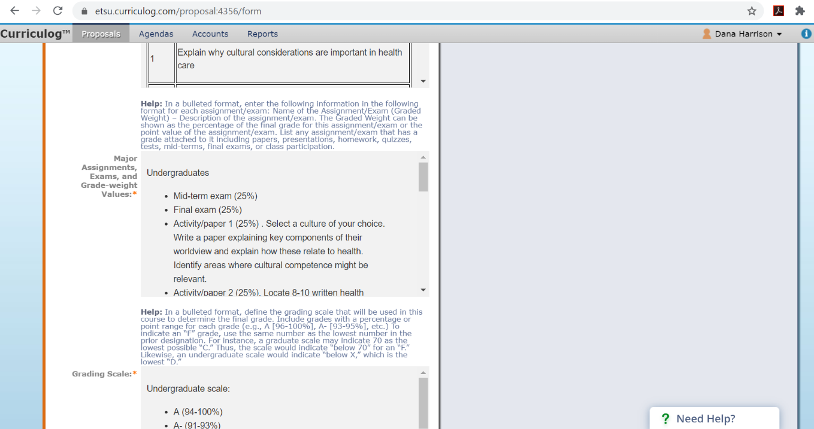

General Proposal Review Tips:
- Are there any similarities to existing courses that could be a concern?
- When reviewing program/concentration proposals, are the credit values, course titles, etc. captured correctly?
- Does all of the content align with the Help instructions (e.g., bulleted lists, tables, start with a verb or answer exactly what the instructions request: why, what, how in the Academic Justification)?

- What is the overall, objective perception of the proposal?
  - Is the course valuable to the curriculum? (e.g., Academic Justification)
  - Are learning outcomes appropriate? (e.g., Expected Learning Outcomes for the course level – Bloom’s Taxonomy, Major Assignments)
  - Is the workload appropriate? (e.g., Major Assignments)
  - Are credits acceptable?
  - Is the proposal aligned with university goals?

- When the review is complete, send an email to everyone listed on the UCC agenda for the specific proposal.
- Minor grammar issues (e.g., missing periods, obvious misspelled word) can be edited within the proposal before the meeting.
- Structural Changes (e.g., learning outcomes, catalog description needs to begin with a verb), can be updated prior to the meeting after agreement between the originator and other reviewers. Reviewers can include notes in the comments section of the proposal to document any major changes that have been made.

Sample Emails
************************************************************************
Email Example 1

Hi Jan,

I was assigned to review your proposal “Substantive Revision of a Degree or Concentration – Foreign Languages Major B.A. (German Concentration)” on behalf of the Undergraduate Curriculum Committee. Another committee member, Kimberly Sell, has also been assigned to specifically review the proposal. Kimberly will be following up in a separate email. During the meeting, the entire Committee will review the proposal. Therefore, this communication is merely a preliminary review to discover anything that might be helpful in advance. If Kimberly or I can answer questions or otherwise assist in this process, please don’t hesitate to contact us.

- Under “Current Curriculum Components” the Major Total Requirement is listed as 33 hours. However, under the “Current and Proposed Program of Study” German Core is listed as 21 credits. Based upon the "Proposed Curriculum Components" section, it appears that the Major Total Requirement has been split into the German Core and the remaining hours are now included in the addition of German Electives. I just wanted to confirm that the German Core and German Electives credits were combined in Major Total Requirement under the “Current Curriculum Components” section. Am I understanding this correctly?
- Under “Current and Proposed Program of Study” the current German Core contains 21 credits, but I am only able to see 6 courses listed. Is there possibly a course missing from the table?
- In the section "Present the Transition Plan for Students Currently in the Program" it states that "all changes in the concentration involve elective courses". I am assuming this is based upon the addition of the 12 German electives credits from the "Proposed Curriculum Components". However, in the "Current and Proposed Program of Study" section, it appears that the German Core contains 3 new courses and 3 prior courses that will be transitioned out of the core. Would it be possible to clarify the changes between the current German Core (or Major Total Requirement) and proposed German Core, as well as, the electives?

I apologize in advance if these questions or comments are a result of confusion on my side. The intent of the questions/comments is to provide you with an opportunity to consider them prior to the UCC’s meeting on Wednesday. Although the course proposal will be unavailable in Curriculog, you will have the opportunity to think about the questions. As previously mentioned, other committee members will also be reviewing the proposal and might have additional questions or comments.
I enjoyed reading the proposal and appreciate your pursuit to enhance the current curriculum.
Please let me know if can be of additional assistance. I hope you have a wonderful weekend.

*****************************************************************************

Email Example 2
Good morning, Karin -

I was assigned to review your proposal “Career and Technical Education Curriculum, Assessment & Classroom Organization” on behalf of the Undergraduate Curriculum Committee. Another committee member, Michelle Chandley, has also been assigned to specifically review the proposal. Michelle will be following up in a separate email. During the meeting, the entire Committee will review the proposal. Therefore, my review was merely preliminary to discover anything that might be helpful in advance. If Michelle or I can answer questions or otherwise assist in this process, please don’t hesitate to contact us.

I originally had one question related to the academic justification and the number of course hours. However, Evelyn Roach commented on this in curriculog Friday, October 4th. I am under the assumption that the mention of hours for licensure will most likely be eliminated. After reviewing the remainder of the proposal, it appears that the goals, learning outcomes and assignments align to achieve the purpose of the course. In addition, the learning outcomes seem to be appropriate for the most part regarding the cross-listed nature of the course. The only question I have is in regards to how the level of the course might differ. For instance, how might the content or depth of material differ beyond the additional learning outcome when a student that has no college experience (as stated as a possibility in the justification) versus a graduate level student enrolls in the course?

As previously mentioned, other committee members will also be reviewing the proposal and might have additional questions or comments.
I enjoyed reading the proposal and appreciate your pursuit to enhance the current curriculum!
Please let me know if can be of additional assistance. I hope you have a wonderful weekend.

************************************************************************

Email Example 3

Good morning, James -
I was assigned to review your proposals “COBH 3000 – Essentials II and COBH 4467/5567 – Emerging Technologies for the Health Professions II” on behalf of the Undergraduate Curriculum Committee prior to the upcoming meeting. Another committee member, Tabitha Fair, is also reviewing the proposal. Tabitha will be following up in a separate email. During the meeting, the entire Committee will review the proposal. Therefore, this communication is merely a preliminary review to discover anything that might be helpful prior to the meeting. If we can answer questions or otherwise assist in this process, please don’t hesitate to contact us.

The following notes include questions for clarification and possible suggestions to consider prior to the meeting.

COBH 3000 – ESSENTIALS II

- Under “Course Catalog Description” the help section suggests the following:
Help: Enter a short, concise and informative description of the course a) beginning with a verb, not “this course,” and b) written in present, not using will. If you include topics in the description, enter "Topics may include ...." Only in specific circumstances should course requirements be included in the description. Examples include major outside-of-class assignments/projects, study abroad, field-based learning, service learning, etc. Do not include prerequisites or corequisites in this description.

I believe the existing description that you’ve developed is interesting, thorough and provides students an understanding of course content. However, the help text suggests a short, concise description and not using the word “will” within the text. Given the help text, is there a way to create a more parsimonious description (perhaps 3 sentences) and removing the word “will” without losing value? This might not be possible but just something to consider prior to the meeting Wednesday.

Original Catalog Description:
Develop public health projects using the essential skills, strategies, and expertise necessary to improve and advance low-resourced settings. Students will develop projects using both low-resource and advanced tools/techniques to create solutions for health challenges. Teams will work with community partners in the creation of solutions for health challenges. These solutions will include community organizing, assessment and evaluation skills. Each project will also include a budget and implementation guide. Examples of solutions for health challenges include low-resource mobility devices for children, low-resource shoes, low-resource prosthetics and biosand water filters.

- Under “Major Assignments, Exams and Grade Weight Values”, how many “components” will be included in the course and how will each be weighted? For example, will there be 3 components: initial assessment, development plan and pilot test? This might be something to consider including since the text mentions multiple components with several due dates. However, this might be difficult to adjust at this time. Perhaps removing the last sentence of the assignment description would eliminate the need to discuss components and point distribution.
The assignment labeled “Hydroponic Food Source” contains a minor typo. I believe the first “a” in the description should be “the”.

- Under “Grade Scale” it indicates that the points range from 0-820, but I believe I am seeing 825 points.
Community Partner Meeting (75 points)
Community Organization Plan (100 points)
Public Health Intervention Project Development (200 points)
Frugal Innovation (50 points)
Project Management (50 points)
Hydroponic Food Source (100 points)
AdaptoPlay Product (100 points)
Doctors without Borders Assessment Toy (100 points)
Quality of Life Improvement in Low-Resource Setting (50 points)

COBH 4467/5567 – EMERGING TECHNOLOGIES FOR THE HEALTH PROFESSIONS II

- The “catalog description” is well developed and concise. Given the “help” text for this section, it is suggested that the word “may” be included after “Topics”.
- Under “Course Purpose and Objectives”, there appear to be a minor typo that can easily be edited in the meeting. There is a typo in the second sentence “Studentsl”. In addition, it is suggested that the stem of the objectives be modified to “The objectives for offering this course are to:”. Finally, the last bullet point should probably read “Provide” versus “Provides”.
- Under “Expected Learning Outcomes” there is a minor typo in the graduate learning outcome #3 “Denonstrate”. This can easily be corrected during the meeting.
- Under “Grade Scale” it indicates that the points range from 0-500 and then 0-900, but I believe I am seeing more than this amount for both levels.
Presentation: Public Health project management theory and challenges (100 points)
Skill Demonstration: Project Management Software (100 points)
Presentation: Public Health - viewed spatially and the accompanying opportunities (100 points)
Skill Demonstration: ArcView Software (100 points)
Presentation (100 points)
Skill Demonstration: Password Protected Document (100 points)
Skill Demonstration: Website Updating (100 points)
Graduate Students Major Assignments: All of the Undergraduate activities plus the following.
Skill Demonstration: Project Management Software (100 points)
Skill Demonstration: Geocoding by Address (100 points)
Skill Demonstration: Information Distribution and Security (100 points)
Skill Demonstration: Basic Website Creation (100 points)

The addition of these courses is exciting! I am sure the changes will be well received by students. I enjoyed reading the proposals and appreciate the pursuit to enhance the current curriculum.

Please let me know if can be of additional assistance. I hope you have a wonderful weekend.
************************************************************************

Email Example 4

Good morning, Jane -

I was assigned to review your proposal “ECED 4180 - Working With Families and the Community from an Emergent Inquiry Perspective” on behalf of the Undergraduate Curriculum Committee. Another committee member, Jennifer Young, has also been assigned to specifically review the proposal. Jennifer will be following up in a separate email. During the meeting, the entire Committee will review the proposal. Therefore, my review was merely preliminary to discover anything that might be helpful in advance. If Jennifer or I can answer questions or otherwise assist in this process, please don’t hesitate to contact us.

After reviewing the course proposal, it appears that the goals, learning outcomes and assignments align to achieve the purpose of the course.

The questions I have are in regards to the course justification. The help text in curriculog suggests the following content for course justification: Explain why your department needs this course, what role the course fills in the curriculum, and how the course supports improvement in the education of the discipline. If appropriate, include peer recommendations from an accreditation review, program review, or academic audit. Spell out titles of a national accrediting agency or other sources. In light of this required content, why does the department need this particular course and how does it improve education of the discipline?

As previously mentioned, other committee members will also be reviewing the proposal and might have additional questions or comments.
I enjoyed reading the proposal and appreciate your pursuit to enhance the current curriculum!
Please let me know if I can be of additional assistance. I hope you have a wonderful weekend.

